**BUSINESS ETIQUETTE IN BRIEF**

THE COMPETITIVE EDGE FOR TODAY’S PROFESSIONAL

Ann Marie Sabath

2013

How to make a positive and powerful first impression:

* Four rules for making a good impression

1. Make your first 10 words count
   * + Thanks messages for first time
     + When possible include the person’s name in the first ten or twelve worlds of conversation
2. Turn into others - Make eye contact. Wear a smile. Your expression can convey energy motivation
3. Walk with purpose - Move with vigor and vitality
4. Be impeccably groomed – keep your hair neat, wear jewelry appropriate to the event and situation

* Seven easy ways to sabotage a first impression

1. Sloppy language
2. Using lazy words
3. Giggling
4. Inappropriate touching
5. Hiding your hands
6. Gumchewing
7. Throat clearing

Professional image tops for men:

* Adapting to the culture of your work place
* Eight common fashion faux pas

1. Always wear a long-sleeve shirt with a suit
2. Make sure your shirt gives the appearance of having been professionally pressed
3. Be sure the tip of your tie touches the top of your belt buckle
4. Wear socks that reach mid-calf to avoid showing a flash of leg
5. When wearing an American-cut jacket (single-breasted), button up when standing or walking. If your jacket has two buttons, button the top one. If it has three, button the center one
6. When wearing a European-cut jacket (double-breasted), button all the buttons when standing or walking
7. Resole shoes with badly worn heels
8. Choose leather or metal watch bands

Professional image tips for women:

* Dressing for success can be tricky
* Your appearance remains one of the main factors that will encourage others to want to work with and for you
* Dress for the job you want, not for the job you have
* High quality suits in navy grey, taupe, and black tones
* Skirts should be no shorter than slightly above the knee and fall no lower than just below mid-calf
* Blouses: Choose tones to benefit the particular suit. Always select blouses of high quality, colors, and styles that are complimentary to you
* Hosiery: Women who wear hosiery in their own skin-tone portray a more conservative image, your best bet is to go conservative
* Shoes: Heels should measure two or three inches in height
* Handbags/briefcases/portfolios
* Glasses
* Jewelry: Earrings, choose those pieces that are simple yet elegant. Watches, beside being functional, the watch you wear is a valuable accessory item
* The rule of thirteen
* Hair: hair that is shoulder-length or shorter gives the most professional appearance

Office etiquette:

* Guest etiquette
  + Inform your receptionist of the visitor’s expected arrival time
  + Request that each guest sign in and wear a name tag
  + When possible, greet your visitor personally in the reception area
  + When someone else shows a guest to your office, walk out from behind your desk to greet the person and offer a handshake as a gesture of hospitality
  + Offer your visitor coffee, unless one of your staff has already done so
* Honing in on your guest’s five senses
  + Seeing – Establish eye contact with your visitor
  + Touching – Greet the person with a confident handshake and end your meeting in the same way
  + Hearing – Use the visitor’s name during your greetings and a few times during your meeting
  + Tasting – Offer the person a beverage. Ask twice. Most people refuse the first time offer out of politeness
  + Smelling – Don’t overwhelm your visitors with your favorite perfume/cologne. Wear enough so that you, not your guest, are aware of your favorite scent
* Smoke signals: Establishing specific no-smoking politics and regulated smoking areas
* Cardinal sins in the work place
  + Never criticize and employee in front of others
  + Always give employees the opportunity to express themselves
  + Never be late for and appointment
* Dealing with interruptions
  + Constant interruptions are not only distracting; they can put a damper on productivity. If you are a manager, maintain an open-door policy for a given hour in the morning and in the afternoon. Encourage your staff to drop by during those times if the question or matter o be discussed will take ten minutes or less
* Meeting manners
  + Meetings matter!
  + Give each person a reason for being present
  + Prepare a written agenda for attendees to follow
  + Be early
  + Begin the meeting on time
  + State the purpose of the meeting
  + Involve each person in attendance
  + Maintain control of the meeting
  + End the meeting promptly
* Podium protocol
  + Be prepared
  + Following the speech
* Cafeteria courtesies
  + Keep the line moving
  + Treat cafeteria workers with respect
  + Be sociable
  + Leave your eating area in the same condition you leave your work area at the end of the day
* When you’re let go
  + Don’t let your emotions overrule your good sense
  + Never burn bridges behind you
  + Be as positive as possible
  + Silence can indeed be golden
  + Be ready to seize and act upon any opportunities that may appear

Business greetings and introductions

* Make the first ten words count!
* Do your want to get someone’s attention?
* The five commandments:

1. Stand up
2. Make eye contact
3. Smile
4. Say your name
5. Shake hands

* Basic pointers for meetings and greetings:
  + Men:
    - Don’t wait for a women to initiate a handshake
    - Always offer the woman your full hand in a handshake. Forget the business of shaking fingers. Offer your full hand
    - Offer a confident handshake to men and women alike
    - Avoid the “my hand over your hand” handshake, as this can be interpreted as a subtle form of one-upmanship
  + Women:
    - Always offer a complete and firm handshake
    - Stand when shaking hands
    - Shake hands with customers and clients, even when you meet the outside the work place
    - Never stay behind the desk when meeting of greeting someone. When shaking hands, the only thing that should be between the two of you is space
    - Shake hand at both the beginning and the end of a meeting
    - Give a handshake indicative of the confident, self-assured person you are
    - Avoid wearing an oversized ring on the right hand, it can hinder others from giving you a firm handshake
* Be an easy person to meet and greet
  + Keep your right hand free
  + If you’re asked to prepare your own name tag, be sure to print your name in large, legible letters
  + When wearing a name tag, place it on your right side

The art of business conversation

* Believe it or not, it’s quite easy to start and sustain a conversation
* How to be perceived as a good listener:
  + Take two
  + Jump on the same wavelength
* When not to talk
  + If your know nothing about the topic under discussion, remain silent
* How to gain control of a conversation:
  + Be open and friendly
  + Take risks
  + Be the first to say “hello”
  + Be genuinely interested in people
  + Be open to new ideas
  + Accept people as they are
* Call screening
  + Have you stopped to think that phone calls would never have to be screened if people would simply identify themselves when placing a call?
* When a caller is disconnected
  + If two colleagues are talking together, the person who initiated the call should call back
* Handing irate callers
  + Let the person speak without the interruption
  + Paraphrase what the person has told you as a way of letting the caller know you have absorbed the message
  + Be sure to use the person’s name a few times during the conversation
  + Explain what you plan to do and then be sure to follow through
  + When appropriate, follow up in writing. If you were able to meet the person’s needs, summarize what you plan to do in writing
* Slash the slang
  + “I’m tied up right now”, “I have someone in my office, may I return your call in about a half hour?”
  + “Hang on”, “May I put you on hold, please?”
  + “Bye-bye”
* Voice mail etiquette
  + Before recording your message, practice it
  + Make it easy for callers to leave messages
* When you are the caller
  + Before dialing, mentally summarize the reason for your call in a few sentences
  + Speak slowly
  + Leave your telephone number
* Car phone finesse
  + When calling someone else’s car phone, identify yourself and ask wether it’s a good time to talk
  + Remember that the clock is running when someone is using a car phone
  + Whenever possible, retrain from putting car-phone users on hold
* Public phone protocol
  + Stand within an arm’s length of the person on the phone so you’re not perceived as eavesdropping
  + Refrain from staring at the person or continuing to look at your watch as a way of trying to get the caller to hang up
  + If, on the other hand, *you’re*the person placing the call, you need only to keep one simple rule in mind: keep the conversation brief. You’re on a public phone!

Business etiquette in correspondence

* Word wisdom
  + “Thank you for your interest in our company’s product”, “It was a pleasure meeting with you today”
* “Marketing” your correspondence
  + Develop a writing style that actually makes people look forward to receiving your correspondences
  + Simple techniques
  + Proofread your letters. Even one misspelled word undercuts the effectiveness of your letter
  + Verify the spelling of all names, first and last
  + Keep each sentence to ten to twelve words. Shorter sentences frequently make a stronger point
  + Keep your letter to one page whenever possible
* Last names should be used when:
  + You are writing to a person you have not met face to face
  + You are writing to a person who has not invited you to use his or her first name
  + The person with whom you are corresponding is matter-of-fact or formal in his or her approach with you
  + You are unsure whether to use the person’s last name or first name in the greeting
* Big correspondence mistakes: A review
  + Using first names when not appropriate
  + Using “Dear Sir/Madam:” in a salutation instead of “To whom it may concern:”
  + Using the word “I” in the first sentence of a letter
  + Presenting written correspondence in a sloppy manner with misspellings, “ white out” corrections, grammatical errors, typos, etc.
  + Failing to make the envelope as professional in appearance as the letter itself
  + Failing to hold the cover letter to one page
* Fax finesse
  + Send your faxes when promised
  + Give your faxes the same professional treatment you do your regular mail
  + Always include a cover sheet stating your name, telephone number, fax number, and any other printed information
  + Correction fluid appears as a blotch when faxed
  + Make a photocopy of any document on colored paper
  + Keep the receipt of each fax transmission
  + Notify the recipient by phone that the fax has been sent
  + Be sensitive about sending more than three or four pages
  + Visa fax unless you’ve been requested to do so
* Memo manners
  + Suggestions:
    - Give your memos the same attention you give the correspondence you send you clients and customers
    - Make your memos efficiency tools
    - When sending a memo to people on the same professional level, list their names in alphabetical order
    - When sending a memo to people on various professional levels, list them by rank
* Proposals with pizzazz
  + Do your homework
  + Prepare a professional and polished cover letter
  + If you receive a telephone call from this potential customer or client, be sure to follow up as soon as possible
  + Once you learn of the decision, send a thank-you letter

The art of mingling

* Invitation etiquette
  + When you are the host or hostess:
    - Send invitations four to six weeks prior to the scheduled event
    - Make it easy for guests to respond to the invitations. Include a reply card with a stamped envelope
  + When you are the guest:
    - Reply to the invitation as son as possible
    - If you’re not able to attend, offer a brief reason
* How to overcome *minglephobia*
  + Before attending a business/social function, create your own itinerary
  + Read body language
  + If you don’t know anyone at the get-together, be honest about it and take the invitation
  + Establish instant rapport
  + After mingling for a while, give your self an “intermission” by talking with people you know
  + Exit the group tactfully by excusing yourself immediately after you have spoken rather than after someone else has finished speaking
  + Take note of the time before going back to the field of unknowns
  + Unless you are part of clean-up committee, don’t be one of last to leave
* The art of being a good guest
  + Arrive promptly
  + If you have been invited to bring your spouse, colleague, or “significant other”, be sure to brief him or her about others who will be there so that he or she can mingle
  + Simply reintroduce yourself by saying your name and initiating a handshake
  + Mingle with people you don’t know as well as with those you do
* Receiving-line manners
  + To avoid congestion, stage your receiving line away from a room’s entrance
  + The host or hostess should retain from drinking while standing in the receiving line
* Buffet etiquette
  + Don’t view the buffet table as your last supper!
  + Return for seconds only if you have been invited by your host or hostess to do so
* Banquet etiquette
  + Make a point of talking with a few people at your table, not just the people on either side
  + Try to include others in the conversation
* Toasting tips
  + If the host or hostess has not proposed a toast, it’s acceptable for a guest to ask whether he or she may make one
  + If the setting is formal, the person initiating the toast should stand at his or her seat when proposing it
  + Toasts should be brief
  + When you are guest, after the person being honored has been toasted, raise your glass and, looking at the honoree, nod your head in a slight bow before taking the first sip
  + If you’re the person being toasted, do not raise your glass as the toast is being made
* Golfcourse propries TEES
  + Always be ready to play when it’s your turn
  + Guests are usually invited to tee off first
  + The golfer furthest from the green always plays first
  + When someone is addressing the ball, stand still and retain from talking
  + Help others enjoy the game by offering compliments like, “nice shot” or “good swing”
  + Safety as much as courtesy dictates that you remain in control of your emotions and retain from immature actions like throwing your club
  + When walking with a hand cart, never pull it across the tee or the green
  + When using a riding cart, be sure to understand and follow the course rules
  + When putting, do not step in your playing partner’s putting line
  + When it comes to building healthy and lasting business and social relationships, your behavior on the gold course is much more important than our score
* The art of gift giving
  + What about thank-you notes? Does a verbal thank-you suffice? If it takes someone longer that fifteen minutes to do something nice for you, a written thank –you is definitely in order

The mechanics of table manners and restaurant etiquette

* Seating with style

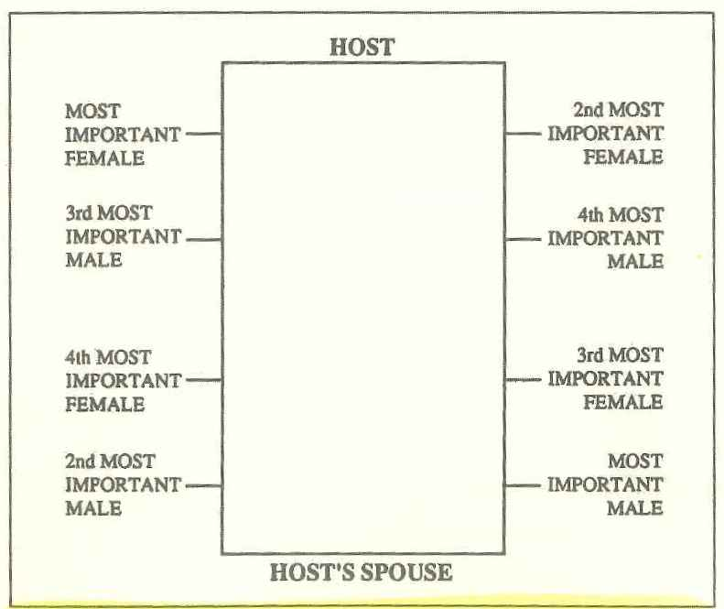

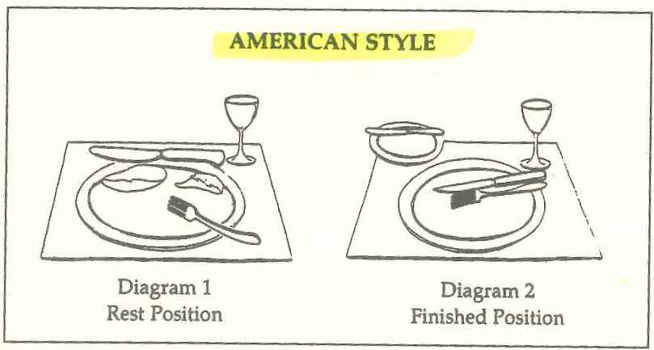

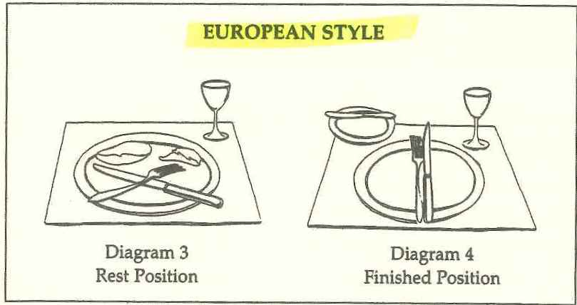

The etiquette of tipping

Etiquette en route

* Flight manners
* “Excuse me. I need to go out”

International etiquette

* Believe it or not … in our jet-set, small-world, global society, there is a universal language. It’s called the smile. This basic gesture, a gift bestowed on human beings and on no other living species, is truly the golden rule for international communications. Unfortunately, things get more complex from that point on.
* Recognize cultural differences
  + The first rule of communication with international colleagues is to recognize that people from other countries have markedly different lifestyles and often work under business systems different from ours
* Handshakes
  + Cultures can often be miles apart in more ways than mere geographic distance
* Communication caveats
  + Guidelines to set the tone when communicating with business people from various backgrounds and cultures:
    - Start slowly
    - Follow the KISS rule. Keep it simple, stupid!

Manners for special occasions

Men and women as colleagues

* Times change, but habits die hard
* On-the-street manners
  + When a man walks on the outside, closest to the curb. We simply appreciate the courtesy
* Women hosts
  + “I’d like my guest to go first”
* Applying lipstick at the table
* Who’s on first
  + If the man is your customer and the woman is your supervisor, the man’s name should be said first
* Elevators
  + “Who should leave the elevator first – man or woman?” the person closest to the door should exit
* Escalators
  + A man should allow a woman to precede him
  + When descending an escalator, it’s most appropriate for a man to precede a woman, turning around to face her as soon as he gets on
* Revolving doors
  + “Let me get the door for you”
  + Whatever you do, don’t get in together!
* Faux pas made by men
  + Addressing female colleagues as “honey”, “dear” or “sweetheart
  + Touching or patting female colleagues rather than greeting them with a handshake
  + Excluding women from the “Old Boys’ network”
* Faux pas made by women
  + Giving only our first names when answering the phone
  + Giggling to fill pauses
  + Not being as friendly with the spouse of male associates as we are with the associates
  + Using foul language in the work place
  + Making personal telephone calls on the job