**THE BALANCED LEADER**

**By Michèle Mees 2011**

(3) I believe that bringing masculine and feminine values into equilibrium can make a significant contribution to the well-being and development of men and women, of companies and of society. The non-existence of the glass ceiling.

Our goal is to contribute to realizing gender balance at all levels of decision-making: not as a final goal but as a means to an end.

(11) **Time for a change**

*The hardest thing to explain is the glaringly evident which everybody has decided not to see*

AYN RAND

(13) **The allegory of the cave**

Plato (428 BC - 347 BC) group behaviors, people's knowledge. Critical thinking has to do with liberating oneself from the way in which one is used to thinking and daring to see things differently.

(14) Most companies are poorly prepared, if prepared at all, for the fact that their personnel and customers have become more critical, better informed, better connected, more assertive and more diverse. Many women feel undervalued and leave the business world.

*Not only is the market changing, but so is a new generation of employees. Young workers have high expectations concerning their work-life balance. They are also strongly focused on the short term, seek variety, and do not wish to work too long on the same project. Motivating young people to commit to projects lasting longer than six months is already a significant achievement. This generation also expects more affective than effective management.* (Saskia Van Uffelen - female CEO IT company)

(16)

|  |  |  |
| --- | --- | --- |
|  | **Emergent workers** | **Traditional workers** |
| **Believe that** | it is up to them and that they must grow in order to make the company successful. | the company is responsible for their career. |
|  | their commitment is based on a reciprocal relationship. | their commitment is based on long-term job security. |
|  | a job is more than earning enough money to live. | companies must always play according to the rules. |
| **Prefer an employer that** | expects them to reflect on new and different ways to get things done. | sets goals and gives clear commands. |
|  | creates opportunities for growth, even if this results in stress. | draws up a clear work schedule. |
|  | allows them to use their creativity and to develop. | creates clarity concerning daily expectations. |
| **They are best suited to** | leadership positions. | positions with consistent content. |
|  | positions that require a high degree of creativity and out-of-the-box thinking. | positions with a clear structure and processes. |
|  | teams with a hands-off manager who stimulates working independently and supports growth. | teams with a hands-on |

(17)

|  |  |  |
| --- | --- | --- |
| **Retention actions** | **Traditional employer** | **Emergent employer** |
| Bonus for top performers | 42% | 68% |
| Training & Development | 84% | 100% |
| Individual career planning | 16% | 55% |
| Developed and accepted corporate culture | 53% | 83% |
| More options related to work-life balance | 34% | 88% |
| Listening to employees in order to understand retention factors | 33% | 65% |
| Coaching programs | 52% | 91% |

(19) **Stress underestimated**

Stress is one of the main reasons people leave their employer. Employees with a healthy work-life balance and unburdened by stress, remain longer at a company and will also recommend it to others.

(21) Nevertheless, attracting and retaining talent remains a crucial success factor for a company's survival.

**Underuse of female talent**

The influx of qualified and talented women in the labor market has never been so high.

(22) Even women without a family and with a clear intent to reach senior management level were behind their male colleagues at each step in their career: men move ahead more quickly and end higher.

Coaching, mentoring and developing one's potential in a company are highly influenced or made possible by one's first managers.

*Women by nature do not work hierarchically. High levels of control and pointing out mistakes are a sure way to destroy self-confidence.*

(23) A 2006 survey of women in higher positions by Opportunity in Business in the Netherlands shows that women leave companies for the following reasons:

* Ready for a new challenge 76%
* Inadequate use and appreciation of qualities 66%
* Not feeling at home in the company culture 66%
* Insufficient day care possibilities 8%
* Not enough part-time work 4%

(24) ING Netherlands

* Little or no career perspectives
* Lack of appreciation: a lack of interest and personal attention;
* The company culture: politicization of the organization, critique not appreciated, lack of harmony, every man for himself, lack of authenticity, too much focus on the short term.

(25) Extreme jobs are well-paid positions in which you work more than 6o hours per week and that fulfil at least five of the following criteria:

* An unpredictable workflow
* Tight deadlines and a high work tempo
* Responsibility transcends a single position Work-related events outside working hours
* Always being available for customers and employees
* Profit & loss responsibility
* Responsibility for mentoring and recruitment
* Regular travel
* Large number of employees in direct line
* Present at least 10 hours a day in the office or workplace

(26) People in extreme jobs do not always notice the exhaustion. Women more than men feel guilty when they go for an extreme job, certainly when this means that other aspects in their lives will suffer.

(27) **Too few managers with social skills**

Strong social or interpersonal communication skills are essential to realizing connection and commitment in a team.

(29) **The pyramid model**

* Hierarchically structured
* Male
* Controlling leadership
* Culture of clones
* Homogeneous
* Winner mentality
* Linear
* A question of status
* Continuity

**(31) Flat network models**

The future. The sustainability. The Balance between prosperity and well-being, a great need for collaboration, humanity and solidarity. Technology.

(34) A revolution in which sustainability and the balance between prosperity and well-being are playing a crucial role.

**Leadership in a new world**

A new form of leadership is needed to transform the old pyramids into new collaborative entities that are open to the diverse influences of a global and local society.

An evolution is underway to flat (virtual) networked organizations, in which space is made for collaboration, co-creation and empathy. The key concepts for the future are all feminine: empathy, collaboration, sustainability, balance, openness, connectedness, collective, inclusive, intuition, dreams, learning, experimenting and well-being.

(39) **Need for innovation**

The needed change is radical. Creating a sustainable economy demands not only an economic, but also a personal transformation.

Linear thinking states that the future must be examined, risk reduced, and the clearest possible image of the future created.

(40) Innovation is critical. Innovation also means creativity. Creativity demands a fresh outlook and an open mind, the courage to see things differently.

(45) **A new view**

*The real voyage of discovery consists not in seeking new landscapes, but in having new eyes*

MARCEL PROUST

(47) **Gender**

Gender stands for the sociocultural aspects of being a man or a woman, the way these are defined in a society, the roles that are assigned to men and women.

If it is society that defines gender roles, it is also possible to change these definitions, in which case people can behave differently if they want.

(49) **Masculine energy**

According to Jung, the masculine archetype emerges from the originally masculine. This concerns masculine energy or yang. The masculine is by nature associated with the following:

* Power that is focused outward
* The urge to action and initiative
* The urge to undertake something, to realize something in the external world
* Goal-oriented, focused
* Creativity
* Feeling proud after achieving the goal
* Competition, the will to win
* Leadership and authority
* Emphasis on becoming versus being
* The urge to push back the boundaries, to innovate
* Taking risks and accepting challenges
* Difficulty in accepting limitations
* Ability to distinguish, to see differences
* Wanting to see oneself as different than others
* Knowledge, order and structure
* Ability to distinguish, to uncouple things from each other
* Wisdom based on knowledge, analysis, understanding
* Focused on the abstract and the pragmatic
* Directness, calling things as they are
* Warrior energy: sacrifice for a cause

(50) **Feminine energy**

This concerns feminine energy or yin. The feminine is by nature associated with the following:

* Waiting in confidence
* Perseverance and toleration
* Patience
* Inner knowledge that things happen as a matter of course
* Inner knowledge that everything changes
* Inner knowledge that creativity flows out of its own accord
* Instinctive knowledge, feeling, intuition
* Holistic thinking based on wholeness, not black and white
* Connectedness with people and nature Connectedness with the here and now
* Enjoying the now
* Connecting with that which is still under development
* Receiving, interconnected dependence
* Acceptance of pain and death as a part of life itself
* Bearing and giving life
* Acceptance of periods of setback, going with the flow
* Nourishing and caring
* Focused on preserving life and safety
* Focused on the personal
* Creating space to allow something new to flourish
* Alertness to danger
* The ability to do many things at once
* Experiencing and feeling the meaning of things
* Desire for significance, meaning, connectedness

**Animus**

The animus is the masculine in the woman and is present in every woman. When a woman succeeds in developing her masculine dimension (also called the yang dimension), her feminine power will also be strengthened. A woman with her masculine and feminine sides in balance is able to fully utilize the positive characteristics of both.

(52) **Anima**

The Anima is the feminine in the man, and is present in every man. If a man succeeds in developing his feminine dimension (also called the yin dimension), this will allow him to utilize the positive elements of his masculine qualities. A man with his masculine and feminine side in balance is able to fully benefit from the positive characteristics of both. He is able to be goal-oriented and open, effective and involved.

(54) **Dominant culture**

The dominant culture is therefore a masculine culture, one in which the feminine is underrepresented.

management guru Tom Peters writes the following:

(55) *Guys like rules. They like commanding and controlling. They like Knowing their place. They like hierarchical structures and the certainties associated therewith. Such structures exist not just because of organizational needs', but rather because hierarchy and male thinking go hand-in-glove - and because men have always (until now) dominate organizations.*

On the other hand, there are also many women in top positions who are out of balance, who have suppressed the feminine in themselves for years. Women who as it were have lost touch with themselves, because for years they have gone out of their way to excel in the world of masculine values. Men also lose the connectedness with their feminine side in this dominantly masculine culture.

(56) **Need for more feminine energy**

Balanced leadership is based on the dynamism of the masculine and feminine in each individual.

(57) **The paradox of the equality ideal**

Stereotypes are politically incorrect and hence more or less a taboo.

(58) The dominant thinking in our society concerns equality, and is based on a nice principle: everyone is equal before the law. All receive the same opportunities and possibilities. No distinction is made based on gender, skin color, age and so on. In fact, such discrimination is against the law. The equality ideal has an ethical dimension that no one can oppose. All are equal. It is wrong to treat people differently based on their external or interior qualities, and/or based on stereotypes.

Stereotypes simply are an intrinsic part of our thinking. Whether we like it or not, they color our perceptions.

Preconceptions of course exist in a team and in a company concerning what is masculine and what is feminine. These unexpressed perceptions naturally influence the way in which women and men progress or stagnate in an organization.

**Recognizing blinders**

A stereotype can only be addressed if it is seen.

**Blinder 1: Men and women do not differ in essence**

A group with only men and a group with only women will differ from each other in the way it thinks, approaches problems, communicates, deals with and solves conflicts, guides one another, encourages one another, and so on.

(60) **Nature versus nurture**

Simone de Beauvoir's quote 'On ne naît pas femme, on le devient" (one is not born a woman but becomes one), all the differences between men and women in society are culturally determined.

Differences in female and male brains

More than 99% of male and female genetic coding is the same. The brains of male and female thinkers do reveal differences in the blood circulation via the brain (the neural activity), the structure of the brain itself and the chemistry' of the brain (the way it is affected by hormonal activity).

(61) Female brains develop the relational, emotive and verbal dimension more strongly. Connecting using words and eye contact. The choice of words is very important here.

The way in which information is processed. Male brains localize information in one or two centers. Female brains tend to relocate information throughout various brain centers.

(62) **Characteristics of the male brain:**

* Better visual and spatial insight
* Ability to reason mathematically
* Assertive
* Direct discussion style
* Focused on doing
* Focused on quick satisfaction
* Focused on possession
* Less susceptible to depression

**Characteristics of the female brain:**

* Better feeling for language
* Empathetic
* Focused on relationships
* Greater sensitivity to smell, color, taste and sound More refined motor activities
* Indirect discussion style
* Better memory
* Better in recognizing faces

(64) **Blinder 2: All are treated equal, we do not discriminate**

The equality ideal inevitably becomes exclusive instead of inclusive. Look at the limited number of women at the top of companies and other social institutions.

The dominant culture is a masculine culture. This means that the criteria on the basis of which someone receives a promotion, is noticed and can develop a career, are set up according to this masculine model.

(65) **Blinder 3: We recruit and promote based exclusively on merit**

Human attitude, which ensures that one is surrounded by like-minded people and clones of themselves. This is not beneficial to the team's diversity and the need for differing opinions. We are also subjective when we project our personal ideas and blinders on others.

(67) Men and women in general approach a promotion or recruitment meeting very differently.

(68) **Blinder 4: We have the same expectations with respect to male and female leaders**

Ten dimensions of leadership behavior were examined for this international study:

* Supporting: encouraging, assisting, and providing resources for others Rewarding: encouragement, giving recognition, providing financial and other rewards
* Mentoring: promoting the skills and career development of others
* Team building: stimulating positive identification and collaboration, conflict resolution
* Networking: developing and maintaining interpersonal relationships that can provide information and/or resources
* Inspiring: motivating others and increasing enthusiasm
* Problem solving: identifying and analyzing obstacles to performance and acting decisively to remove them
* Influencing upward: influencing people higher up in the hierarchy
* Delegating: allowing others to take real responsibility
* Consulting: checking with others before taking decisions that affect them

(71) **Blinder 5: Women have less ambition than men**

"Do women in fact want to move up?" Or "Are women as ambitious as men?"

(73) **Blinder 6: Leadership has nothing to do with masculine or feminine**

Leadership for the future, balanced leadership, has everything to do with masculine and feminine.

(74) An inclusive organization knows precisely how to utilize the power of diversity and score better in creativity, innovation, openness, productivity and so on. To manage a diverse team, you must be open for this variety and connect with it.

(79) **Iceberg model** People are normally so focused on the top part that they lose sight of what lies below. (McClelland's).

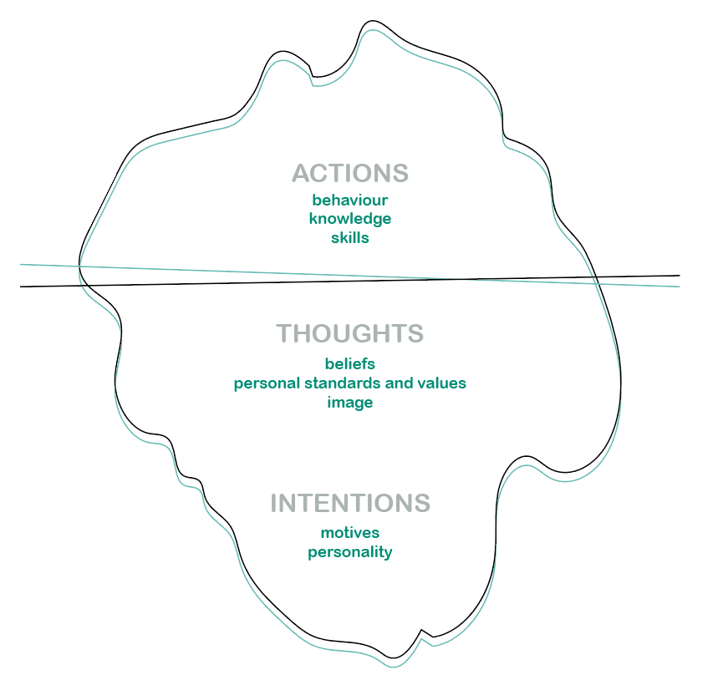

(81) **Awareness development model**

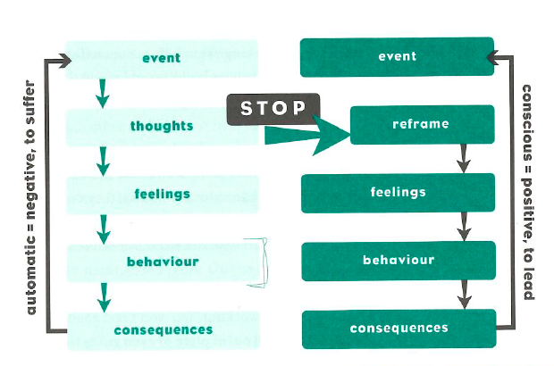

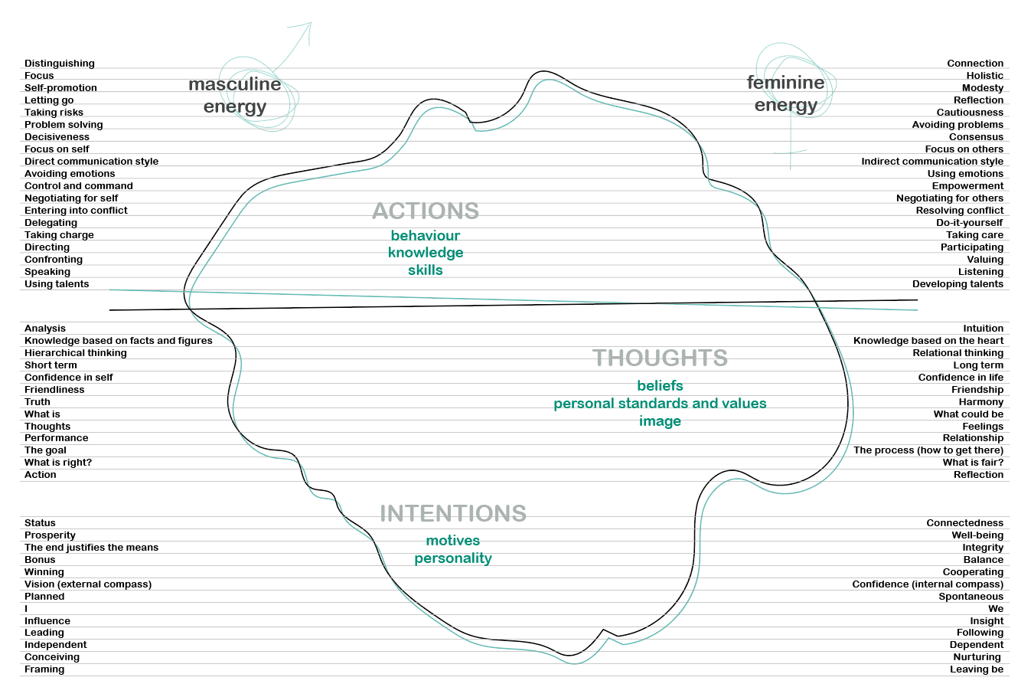(84 – 85)

(86) **Differences in the workspace**

* Different negotiating strategies
* Different communication styles
* Different ways of networking: lack of time due to too much work. Running a household and perhaps some other caring tasks besides.

(97) **Characteristics of balance leader**

* Open
* Collaborative
* Can allow themselves to be vulnerable
* Show emotions
* Make real connections with people
* Do not claim to have all
* Very good at listening
* Authentic
* Committed, put people first
* Create pleasure in work
* Inspire others to develop
* Not afraid of risk
* Seek out new paths

(98) **An integrated animus/anima**

*Everything that irritates us about others can lead us to an understanding of ourselves.* CARL GUSTAV JUNG

Personal development, courage to step out of their comfort zone.

(99) A woman who can integrate her animus gains clarity and impact. Her access to masculine energy makes her more complete, stronger and softer as a woman.

**Free in relation to others**

**Engaged with self, team and society**

**(101)**

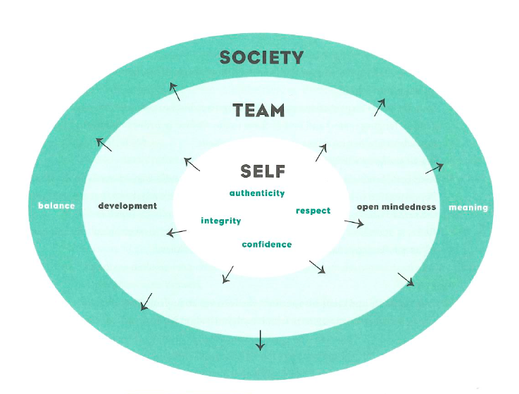

(102) **SELF (CONNECTION)**

**AUTHENTICITY**

* Makes space for his personal development.
* Develops self-knowledge and is therefore more aware of his/her behavior and its impact on others.
* Is aware of the impact of stereotyping, recognizes his/her own stereotypes (culture, gender, language, etc.) and brings them to the surface in order to neutralize them.
* Can admit his/her mistakes and learn from them.
* Shows modesty and can ask for and accept help.
* Feels comfortable dealing with his/her emotions and can assist others to do the same.
* Pays attention to his/her thoughts and behavior and can adjust his/her behavior to the sensitivities of others, even if they are very different from him/her.
* Reflects upon how gender and cultural differences affect his/her behavior and can adjust his/her approach to form connections with others.

**RESPECT**

* Is empathetic and takes into account the feelings and opinions of others.
* Creates a safe environment in which each individual feels valued.

**INTEGRITY**

* Can take action and makes decisions which do not directly benefit him/herself.
* Is aware of preferences based on gender and culture when recruiting and promoting employees and can see beyond this to the intrinsic qualities of each candidate.

**CONFIDENCE**

* Has confidence in him/herself and his/her ability and can therefore inspire confidence in others even if they are very different from him/her.
* Is aware of differences in self-confidence and can empower people with less self-confidence.

(103) **TEAM (COMMITMENT)**

**COMMUNICATION**

* Actively seeks information and passes it on without distinguishing based on gender, culture or other factors. Actively requests 360° feedback about the degree of inclusivity of his/her behavior.
* Gives employees and team members honest feedback regardless of gender, culture or other factors.
* Is aware of gender differences with regard to confrontation and appreciation.
* Organizes dialogue and creates an inclusive working environment in which everyone can express him/herself.
* Makes sure that all participants have their say at a meeting, regardless of gender, culture, communication style (extrovert, introvert), etc.
* Encourages everyone to participate actively in meetings.
* Is aware of gender and culture differences in communication style and takes this into account.
* Is able to broach/resolve conflicts openly and respectfully.

**DEVELOPMENT**

* Can build a diverse team and embrace/manage this diversity.
* Actively supports employees in their personal development.
* Provides training and coaching for his/her employees and ensures that take-up of this is evenly distributed according to gender, culture, etc.
* Provides equal access to internal and external networks for employees, regardless of gender, culture or other factors.
* Encourages employees to find a mentor and provides access to mentoring for everyone.
* Is a valued source of insight and advice for employees and peers and passes on insight to everyone.

(104) **OPEN MINDEDNESS**

* Is a role model for an inclusive policy.
* Sees diversity as an opportunity and is not afraid of managing diverse teams.
* Is aware of his/her own values and standards, and is open to and tolerant of other values and standards.
* Can realize the added value of diverse talents, approaches and ways of working in his/her team.
* Can form connections with others within the broad scale of beliefs/faiths/attitudes to life.
* Shows and demands respect for beliefs and attitudes of others and him/herself.
* Does not show preference for or condemnation of others.
* Seeks and finds a balance between confrontation and harmony.
* Can motivate people even if they have a different attitude. Brings out the best in people and makes sure that they receive the credit for their work.
* Can reconcile differences by connecting people with shared values.

**SOCIETY (ENGAGEMENT)**

**BALANCE**

* Pays attention to the personal balance/well-being of employees and discusses this with them.
* Fosters an environment where both the quality of output (goal) and the quality of mutual relationships and processes (process) are valued.
* Makes room for humor.
* Develops the talents of his/her employees and makes them visible to the team.
* Puts the well-being of team members above personal goals.
* Understands that people are motivated by different drivers and takes this into account for their personal well-being.
* Seeks and facilitates solutions to improve balance between team members.
* Coaches team members to find the optimal balance between energy givers and takers.
* Takes into account the fact that people need space to be creative and provides this space/time/scope.

(105) **MEANING**

* Facilitates the co-creation of a shared vision in order to create transparency within the organization.
* Understands that individuals can only sign up to the goals of the organization through a shared vision.
* Recognizes that giving meaning can vary depending on gender and culture.

(109)

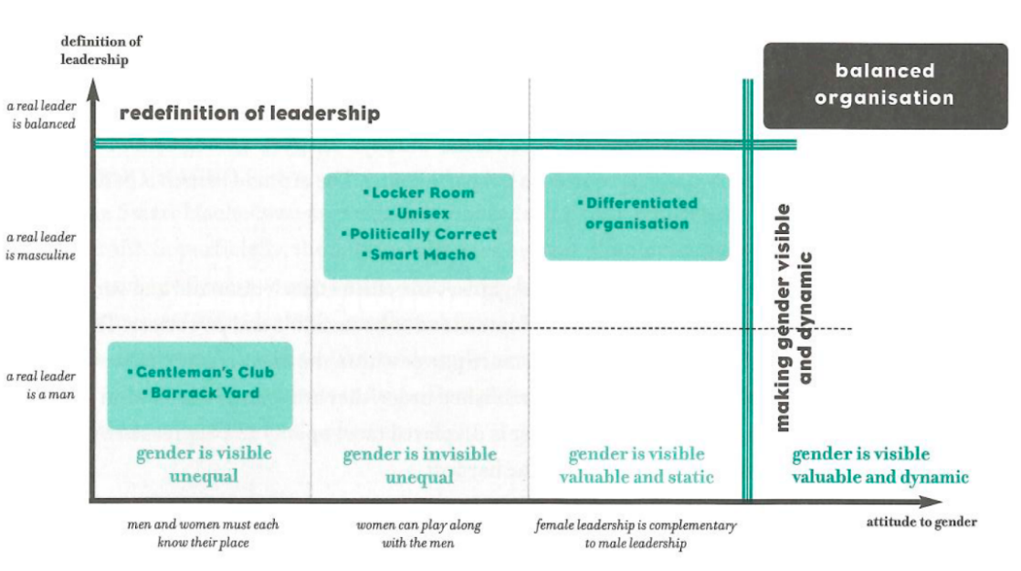

(115) **Q&A**

**Shouldn’t women just fit in with the masculine business environment?**

(116 – 117) **Don’t people prefer to work for a strong male boss?**

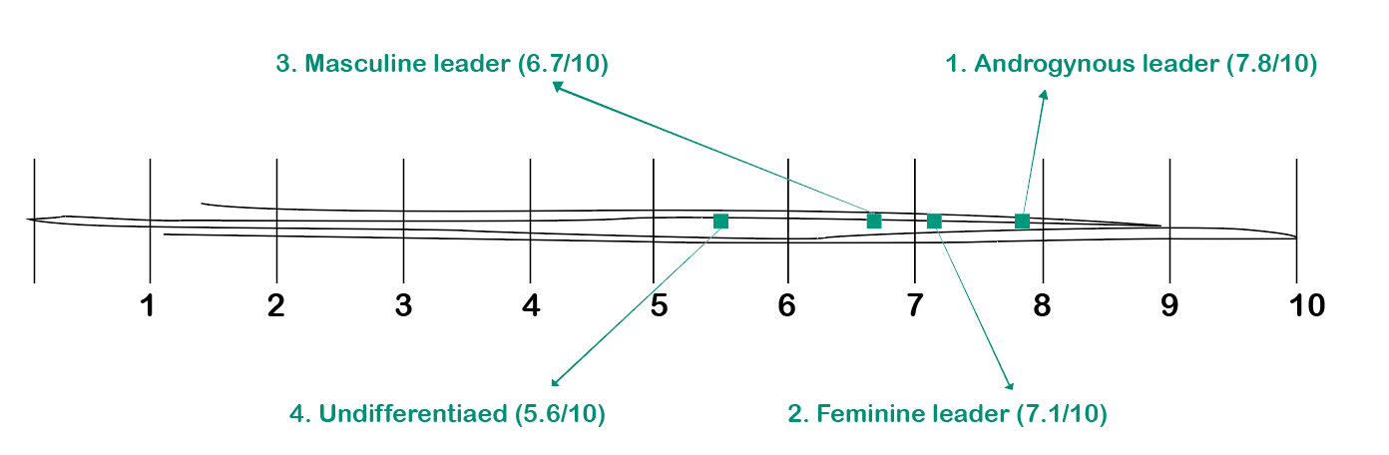(118) **Is balance leadership harder for men than for women?**

(119) **What role do the culture and society in which we live play?**

(121) **Is it possible to bring balance to the team?**

(123) **How can team become better balanced?**

Masculine energy is focused on the goal and seeks solutions or ways of achieving the goal in as short a time as possible or by as direct a route as possible. Feminine energy is also focused on the goal, but will choose a different route to reach it, not necessarily or even likely the most direct. The process of finding solutions is just as important as the solutions. The vision and method are more holistic and inclusive.

(124) Are we ready for balanced leaders?

Organizations also get the leaders they deserve: a balanced leader can only enable him/herself and others to flourish in an environment that is prepared to take off the blinders.

(125) **Who will instigate the change to more balanced leadership?**

Change will mainly come from individuals.

(126) **Advantages of balanced leadership** Better results

(127) **Attention to masculine and feminine values**

(128) **Added value of diversity**

(129) Balanced leadership involves achieving a balance between the inner masculine and feminine sides.

Balanced leaders have integrated their animus/anima, making them free in their relationships with others. Balanced leadership can only develop in a balanced organization. Balanced organizations pay attention to the interplay of masculine and feminine values.

(133)

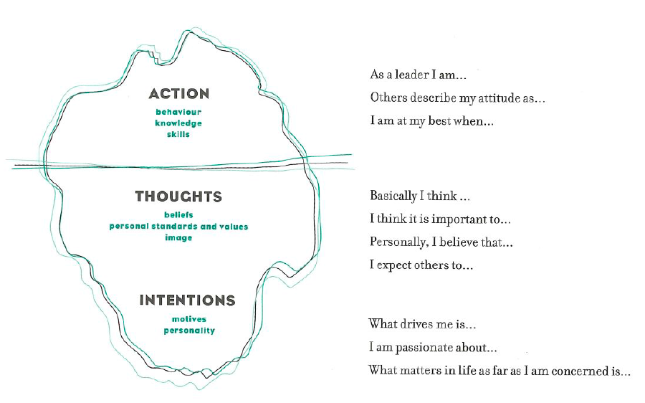

(134)

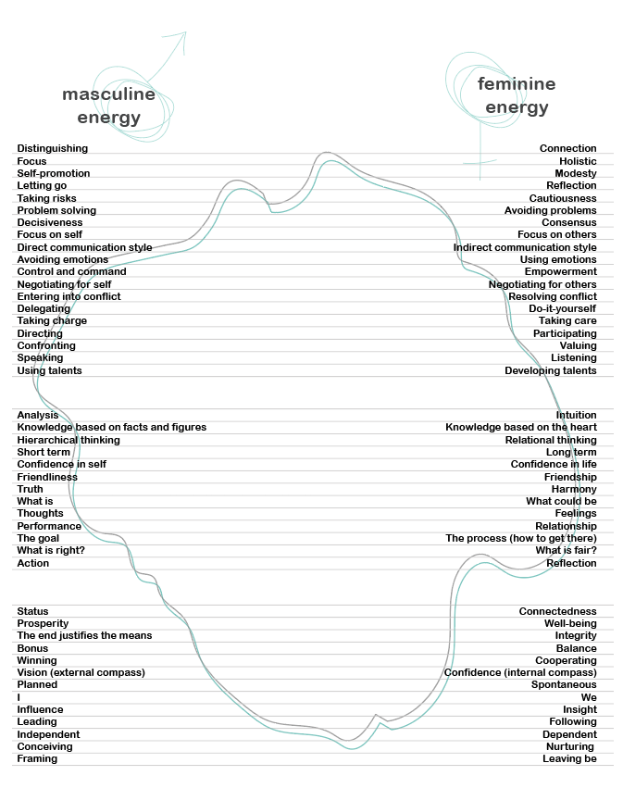

(147)

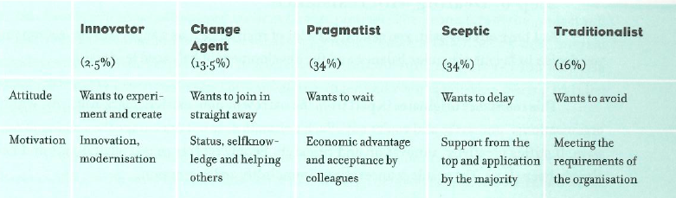

(137) Centre for Balance Leadership

[www.femco.be](http://www.femco.be)