30 MINUTES TO WRITE A MARKETING PLAN

By John Wastwood

(5) Objectives, plans, policies, procedures, strategies and tactics. The marketing plan sets out the marketing objectives of the company and suggests strategies for achieving them. It does not include all the company’s objectives and strategies. There will also be production, financial and personnel objectives.

(6) What is selling?

Selling is a straightforward concept which involves persuading a customer to buy a product. However, it is only one aspect of the marketing process.

What is marketing?

The provision of goods or services to meet consumers “needs”.

(7) Marketing therefore means considering:

* The abilities of the company
* The requirements of the customer
* The marketing environment

The marketing mix, or the four Ps relate to:

* The product sold (product)
* The pricing policy (price)
* How the product is promoted (promotion)
* Methods of distribution (place)

The marketing planning process involves:

* Carrying our marketing research within and outside the company
* Looking at the company’s strengths and weaknesses
* Making assumptions
* Forecasting
* Setting marketing objectives
* Generating marketing strategies
* Defining programs
* Setting budgets
* Reviewing the results and revising the objectives, strategies or programs

Marketing planning will:

* Make better use of company resources to identify marketing opportunities
* Encourage team spirit and company identity
* Help the company to move towards achieving its goals

Marketing planning is a continuous process, so the plan will need to be reviewed and updated as it is implemented.

(9) The marketing planning process:

Set corporate objectives

Carry out external marketing research

Carry out internal marketing research

Carry out SWOT analysis

Make assumptions

Set marketing objectives and estimate expected results

Generate marketing strategies/action plans

Define programs including advertising/promotions plan

Set budgets

Write plan

Communicate plan

Use control system

Review and update

(10) The marketing audit is a detailed examination of the company’s marketing environment, specific marketing activities and internal marketing system.

(11) Market research –collecting information about your markets and then analyzing it in the context of the marketing of the products.

Market research: Combination of in-house experience sales force market intelligence and marketing research.

Market research is used to:

● Give description of the market

● Monitor how the market changes

● Decide on actions to be taken and evaluate the results

Primary data: comes from the marketplace.

(12) Secondary data

Market information needs to cover:

● The market size

● Its characteristics

● The state of the market

● How well are companies doing?

● Channels of distribution

● Methods of communication

● Financial

● Legal

● Developments

(13) Product information: Relates to your own company, your competitors and the customers:

● Potential customers

● Your own company

● Your competitors

(14) Product lines or market segments. Key market segments.

(15) Different customers have different needs. Market segments:

* By geographical area
* By industry or industry sub-sector
* By product
* By application
* By size or end-user
* By distribution channel –distributor, equipment manufacturer, end-user.

Segmentation can also be based on:

* Order size
* Order frequency
* Type of decision-maker

Information checklist. Information required:

1. Sales history. The last three years’ sales by value (including margins where available) for:

* Sales areas/regions
* Product groups
* Main equipment and spares
* Numbers of units by model/size

1. Customers. Total number of customers by:

* Sales area
* Products bought
* Industry sector, eg food/water/chemicals
* Key customers, ie top 40 by sales turnover

1. Competition:

* Who are the competitors for each product group?
* What are the market shares for each product for each competitor?

(19) SWOT analysis: ‘Strengths and Weaknesses as they relate to our Opportunities and Threats in the marketplace.’

Company SWOT analysis:

|  |  |
| --- | --- |
| **Strengths**  -Part of large UK group  -Good image –quality company  -Good resources -financial  -technical  -High level of export sales | **Weaknesses**  -Low level of sales in UK  -Thought of as ‘old fashioned’  -Few marketing staff |
| **Opportunities**  -Parent company is investing in new marketing department  -New group R&D facility  -To develop new products  -To open low cost factory in Asia | **Threats**  -Low priced products from the Far East  -Low-priced products from the USA |

(21) Objectives are what we want to achieve; strategies are how we get here.

(22) Marketing objectives relate to any of the following:

● Selling existing products into existing markets

● Selling existing products into new markets

● Selling new products into existing markets

● Selling new products into new markets

All plans should include marketing objectives for the following:

● Sales turnover for the period of the plan by product and market segment

● Market share for the period of the plan by product and market segment

● Gross profit on sales

(23) Product life-cycle curve

**Sales**

**Early**

**growth**

**Rapid**

**growth**

**Introduction**

**Time**

**Mature**

**stage**

**Decline**

**Saturation**

(24) **Stars**- high market share/high market growth (cash neutral)

**Cash cows**- high market share/low market growth (cash generation)

**Question marks**- low market share/high market growth (cash drain)

**Dogs**- low market share/low market growth (cash neutral)

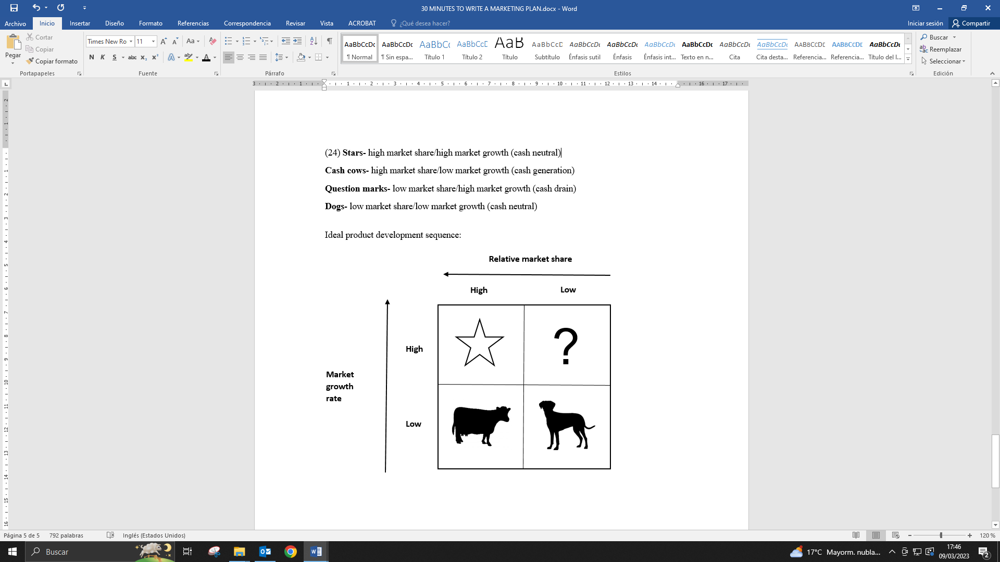

(27) Example of a product portfolio matrix:

**Relative market share**

**0.3:1**

**1:1**

**3:1**

**0%**

**10%**

**20%**

**Market**

**Growth**

**rate**

|  |  |
| --- | --- |
| **Type A** | **PACKAGES**  **Type K** |
| **Type S** | **BALL VALVES** |

(28) Marking strategies relate to general policies for the following:

|  |  |
| --- | --- |
| * Products | * Changing product portfolio/mix * Dropping, adding or modifying products * Changing design, quality or performance * Consolidating/standardising |
| * Price | * Changing price, term or conditions for particular product groups in particular market segments * Skimming policies * Discount policies |
| * Promotion | * Changing selling/salesforce organization * Changing advertising or sales promotion * Changing public relations policy * Increasing/decreasing exhibition coverage |
| * Distribution | * Changing channels * Improving service |

(29) Different types of strategy:

**Defensive strategies:** Designed to prevent loss of existing customers.

**Developing strategies**: Designed to offer existing customer a wider range of your products or services.

**Attacking strategies:** Designed to generate business though new customers.

Ansoff Matrix – the risks of various strategies

|  |  |  |  |
| --- | --- | --- | --- |
|  | | **Low risk** | **High risk** |
| **Present product** | **New product** |
| **Low risk** | **Present market** | Expand existing market with existing product | Develop new products for existing markets |
| **High risk** | **New market** | Sell present product in new markets | Develop or acquire new products to sell into new markets |

(30) Each action plan should include:

● Current position –where you are now

● Aims –what to do/where do you want to go?

● Action –what you need to do to get there

● Person responsible –who will do it?

● Start date

● Finish date

● Budgeted cost

(32) Distribution involves:

● Marketing channels

● Physical distribution

● Customer service

(33) Marketing channels:

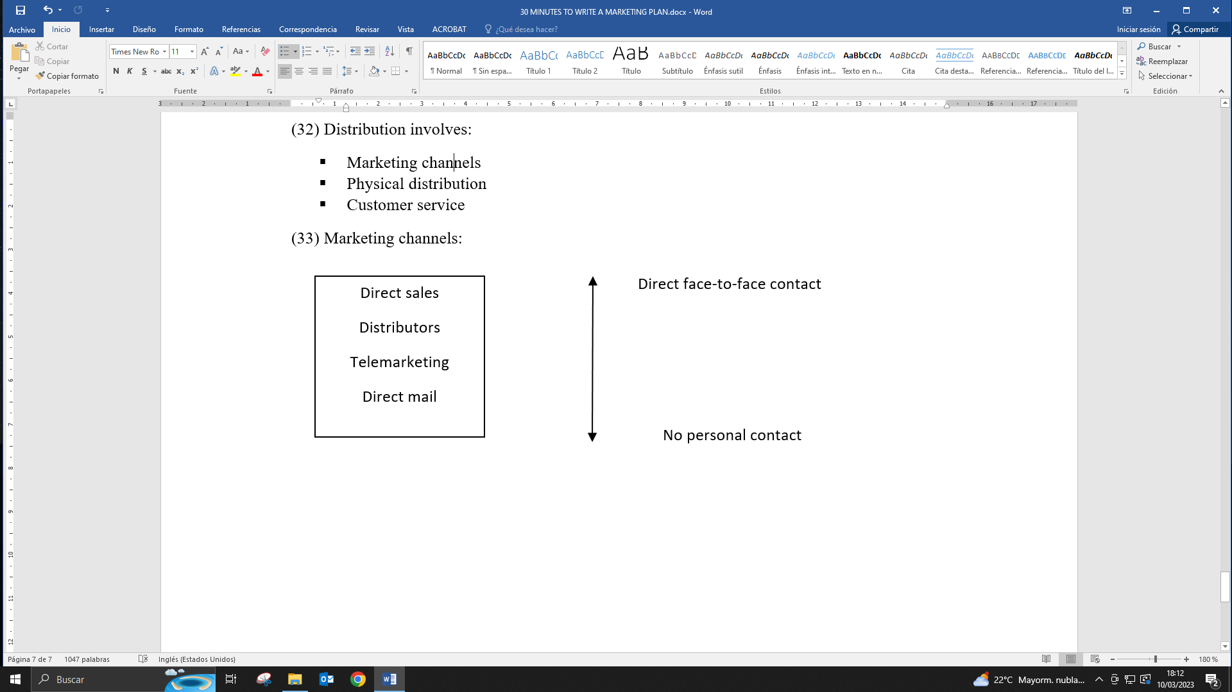

(34) The influence of product characteristics on distribution channels:

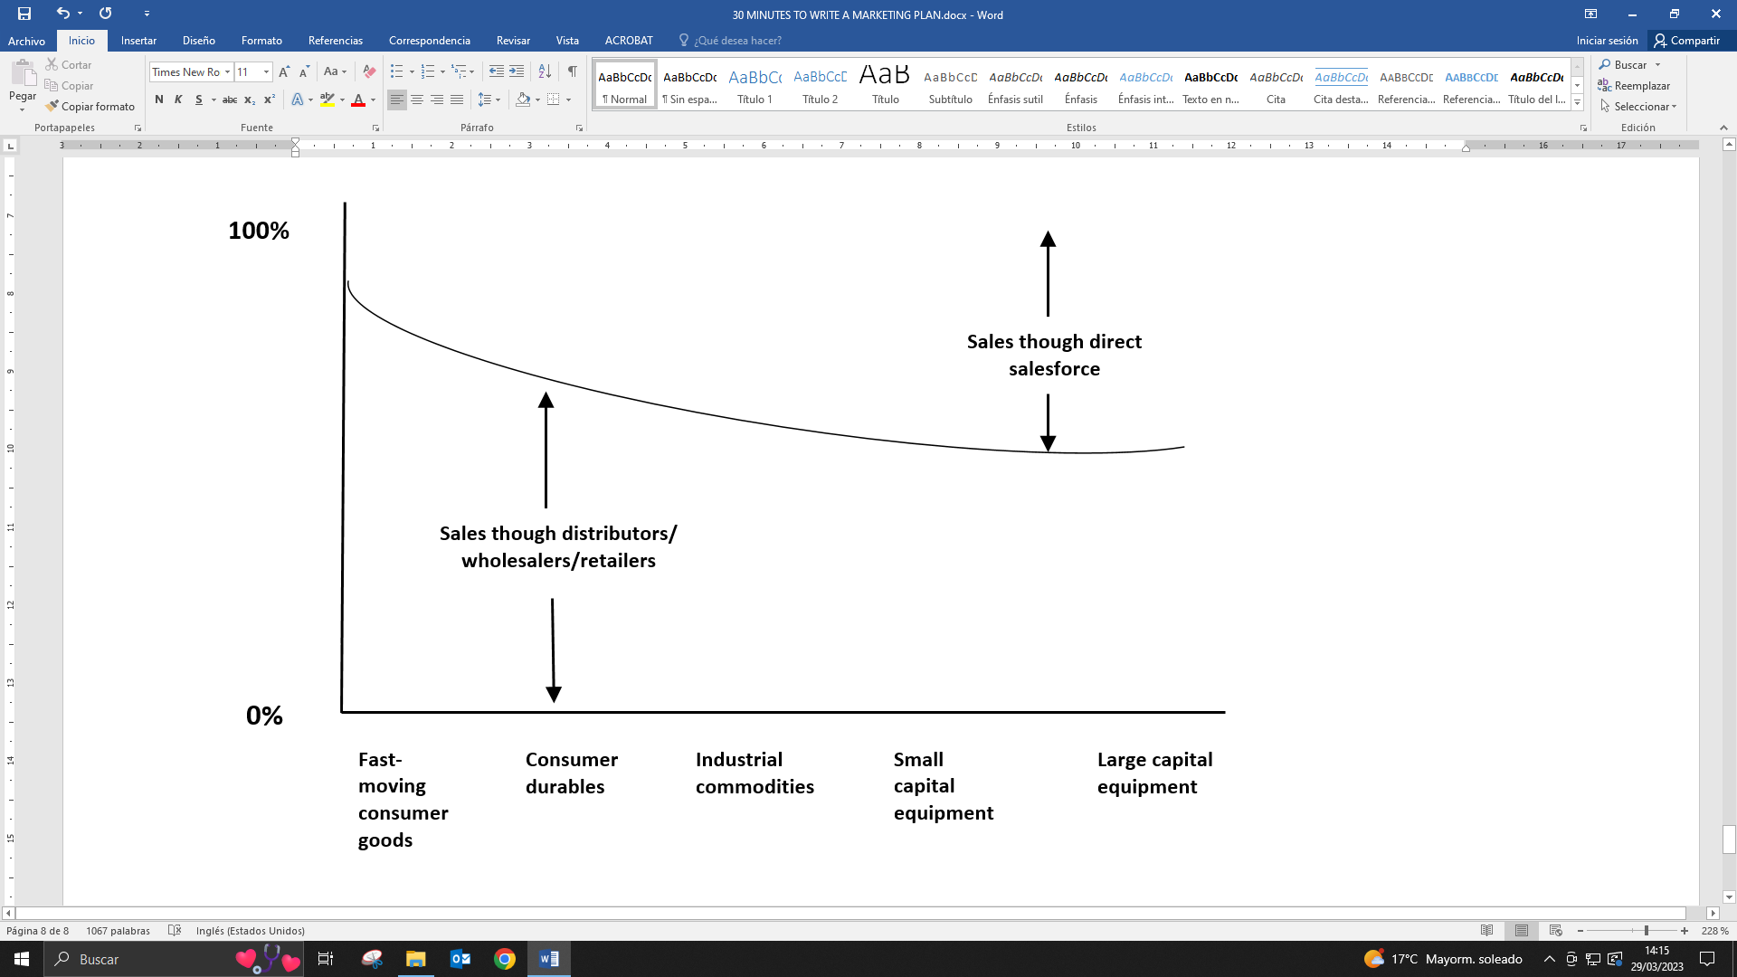

The advantages of personal selling are:

* It allows two-way communication between the buyer and seller.
* The salesperson can tailor the presentation to the individual needs of the customer.
* The salesperson comes to know and be known by the customers.
* The salesperson can negotiate directly on price, delivery and discounts.
* The salesperson can close the sale.
* The salesperson can monitor customer satisfaction levels.

(35) Telemarketing involves selling and marketing by telephone rather than by direct physical contact.

* The man advantages of telemarketing:
* More cost effective than direct sales force.
* Frees up salesperson’s time by reducing routine calling activity.
* Increases frequency of customer contact.
* Allows dormant accounts to be revived.

(38) Advertising and promotions

The purpose of advertising is to get a message across to the customer. Advertising operates at three levels –it informs, persuades and reinforces. Advertising to inform normally relates to the promotion of new products and normally relates to the promotion of new products and services. Advertising to persuade is what most people understand as advertising. There is also the public relations side of advertising: promotional public relations, which includes media relations and exhibitions.

(39) Cost and budgets

Strategies and action plans may be feasible, but are they cost-effective?

(40) Schedule of expenditure for a major exhibition

Exhibition costs

Name of exhibition: International Water

Location: NEC Birmingham

Date: 6th-8th November 19x6

Stand size: 64m² (8m x 8m)

Stand contractor: Exhibition Contractors Ltd

*Costs*

€

Stand space rental 8000

Design, supply and build 10.000

Artwork, photographic panels 5000

Rental of carpets, furniture lights, phone, etc 3000

Hotel bills/expenditure for stand staff 2000

Totals 28.000

(41) An example of a profit and loss account

€000

Turnover 6000

Less Cost of sales __4000_

Gross profit 2000

Less Distribution costs 100

Operating expenses 850_

_950_

Operating profit 1050

(43) Budgeting for additional sales

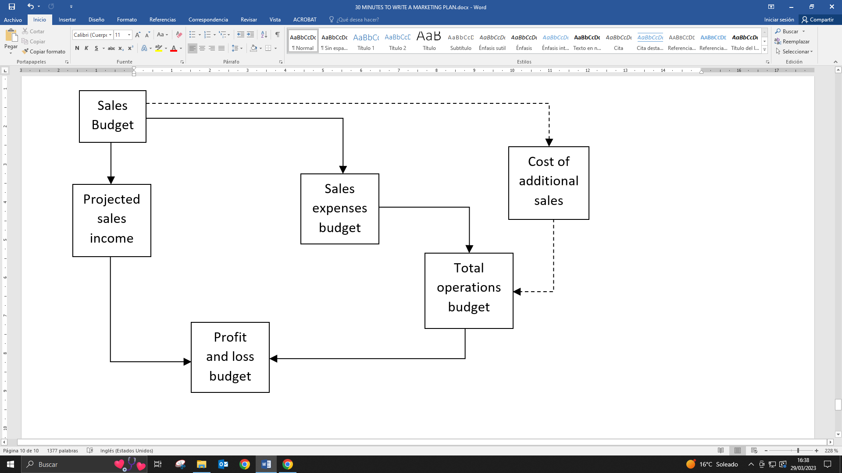

(45) The effect on the profit and loss account of the additional operating expenses for implementing a marketing plan.

|  |  |  |  |
| --- | --- | --- | --- |
|  | 19X6 | 19X7 | 19X8 |
|  | €k | €k | €k |
| Invoiced sales | 260,0 | 576,0 | 937,0 |
| Cost of sales | 158,6 | 339,0 | 534,1 |
| Gross profit | 101,4 | 236,2 | 402,9 |
| Sales & marketing costs |  |  |  |
| Salaries | 75,0 | 78,0 | 81,0 |
| Recruitment | 6,0 |  |  |
| Travel/ent | 7,0 | 7,6 | 7,9 |
| Car costs | 6,0 | 6,2 | 6,5 |
| Advertising | 11,0 | 11,5 | 12,0 |
| Exhibitions | 28,0 |  | 15,0 |
| Literature | 5,0 | 25,0 | 20,0 |
| Sundry items |  | 5,0 | 6,0 |
| Total sales costs | 138,0 | 133,3 | 148,5 |
| Administration costs | 20,0 | 20,8 | 21,6 |
| Data processing costs | 5,0 | 5,5 | 6,0 |
| Distribution costs | 6,9 | 7,2 | 7,5 |
| Total operating expenses | 169,9 | 166,8 | 183,6 |
| (Relating to plan) |  |  |  |
| Operating profit | (68,5) | 69,4 | 219,3 |
| (Relating to plan) |  |  |  |

(48) Contents list of a complete marketing plan

|  |  |  |  |
| --- | --- | --- | --- |
|  | *Contents* |  |  |
| Section | Title |  | Page |
| 1 | Introduction  Executive summary |  | 2 |
| 2 | Situation analysis |  | 3 |
| 3 |  | -Assumptions | 4 |
|  |  | -Sales (history/budget) | 5 |
|  |  | -Strategic markets | 7 |
|  |  | -Key products | 9 |
|  |  | -Key sales areas | 11 |
| 4 | Marketing objectives |  | 13 |
| 5 | Marketing strategies |  | 14 |
| 6 | Schedules |  | 18 |
| 7 | Sales promotion |  | 19 |
| 8 | Budgets |  | 20 |
| 9 | Profit and loss account |  | 22 |
| 10 | Controls |  | 23 |
| 11 | Update procedures |  | 24 |
|  | Appendix 1 |  | 26 |
|  | Appendix 2 |  | 32 |

(50) The external and internal analysis should include only the summaries of the external and internal marketing research and the key resulting SWOT analysis.

(53) Graphic representation of strategic markets

**Company strategic markets 19 X 5**

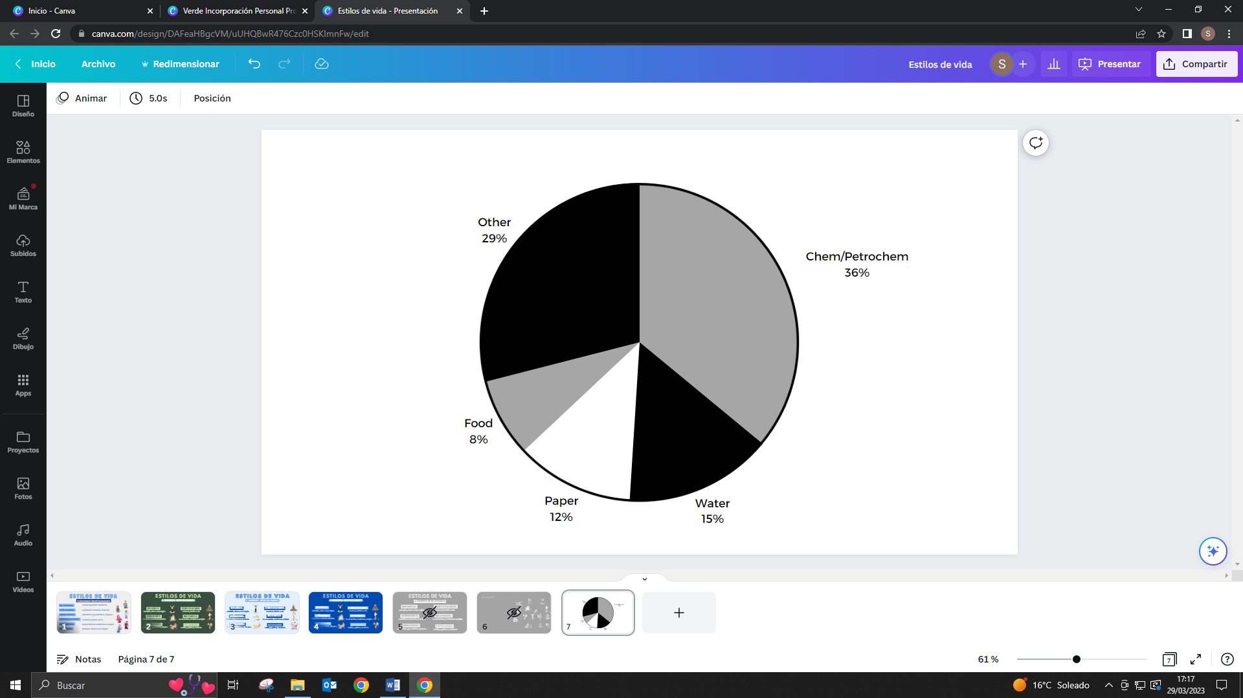

**Company strategic markets 19 X 8**

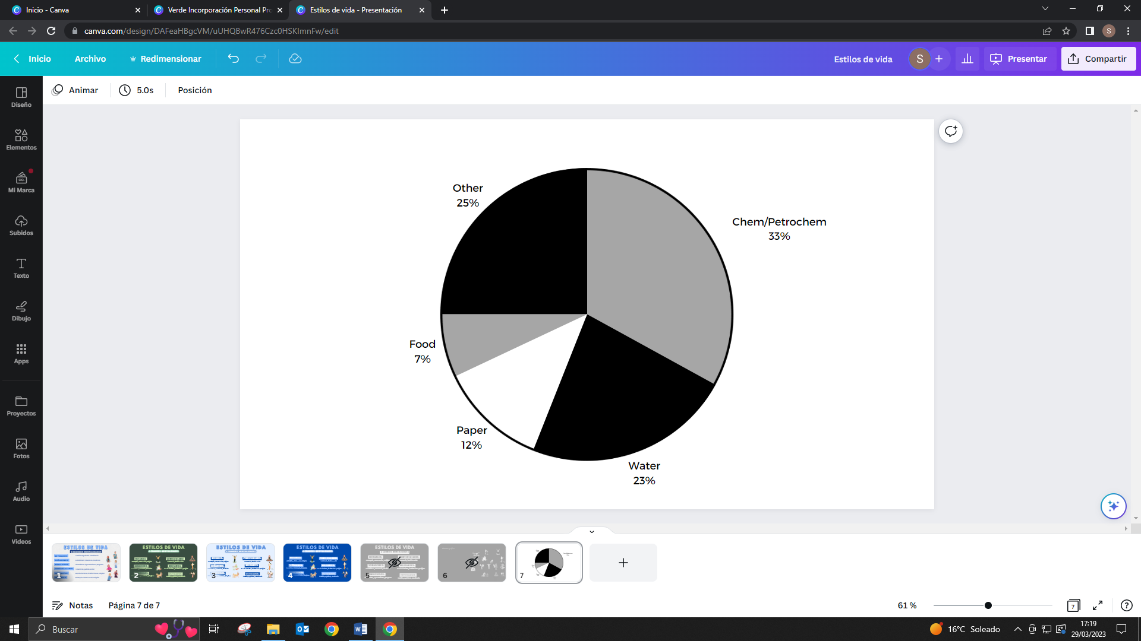

(54) Marketing objectives

* To increase UK sales by 10 per cent per year in real terms for the next three years.
* To double ball valve sales to the water industry within three years.
* To increase sales of packages to 50 units within three years.
* To double distributor sales in Scotland and NI by 19X8
* To increase overall gross margins from 29 to 43 per cent by 19X8

(55) Marketing strategies

* Strategies relating to products
* Strategies relating to pricing
* Strategies relating to advertising/promotion
* Strategies relating to distribution

*Products*

* Package products

*Pricing*

* Discount policy
* Penetration policy

*Promotion*

* Increase advertising
* Increase exhibition

*Distribution*

* Increase own sales coverage

(56) Example of a master schedule

|  |  |  |  |  |
| --- | --- | --- | --- | --- |
|  | Master schedule | |  |  |
|  | Area: UK | |  |  |
|  | Year: 19X6 | |  |  |
| Month | 1 2 3 4 5 6 7 8 9 10 11 12 | | Responsibility | |
| Action plan |  |  | Dept | Person |
| Restructure |  |  | Executive | RLT |
| Mail shot |  |  | Marketing | AJK |
| Advertising |  |  | Marketing | AJK |
| Exhibitions |  |  | Marketing | AJK |
| Pricing |  |  | Sales | EGM |
| Distribution |  |  | Marketing | AJK |
| Market analysis |  |  | Marketing | AJK |
| Product design |  |  | Engineering | TRG |

Controls and update procedures

The control process involves:

* Establishing standards: There should take into account budgeted sales and costs and the time-scales for the implementation of the action plans.
* Measuring performance: this means comparing actual performance against the standards.
* Proposing measures to correct deviations from the standard and detailing corrective procedures to be implemented if the variation from standard exceeds certain limits. These limits should be defined in the written plan.