**I WISH I’D KNOWN THAT EARLIER IN MY CAREER**

By Marty Seldman, 2011

**INTRODUCTION**

Why We Don't Move Ahead- Politics.

She spoke the truth to power and suffered the consequences.

Things haven't changed much in the past four decades; unfortunately, many women still overlook the political aspects of the workplace.

For anyone, male or female, being able to navigate the political waters inside organizations is a critical leadership skill and a building block for success. Is about building coalitions and managing company affairs.

Politics: can be negative or positive it.

* The positive definition of organizational politics: Building coalitions for the good of the organization.
* The negative side of politics: Building coalitions for the good of the self only.

A savvy manager knows the unwritten rules at work but rarely talks about them.

But if we don't learn these skills, we'll never get ahead.

(2) Politics is a fact of organizational life and needs to be put into proper perspective.

Politics fundamentally is about power, power bases, power sources, power shifts and power dynamics.

(8) Too many talented individuals are passed over for promotions, made redundant or leave organizations because they either don't understand how to work with politics, or they refuse to do so.

(14) "My work speaks for itself."

Hard work is necessary, but productivity without visibility is not, and rarely over shadows self-promotion.

Ask yourself:

* What do I know that can be shared?
* What will help others and also help the organization?

(15) **TIPS FOR SELF-PROMOTION**

* What are you known for?
* What have you achieved?
* Who do you know?
* How connected are you?

(18)

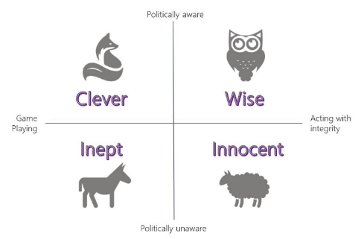

Model using animals to depict the various levels of political awareness and behavior within individuals and organizations. Source: Adapted from Baddelev and James (1987)

(42)

1. Understanding power and negotiating shifts.
2. Dress the part.

(47) Before a merger, change or leadership shift.

* A good understanding of politics at play.
* A thorough awareness of power dynamics.
* A detailed list of stakeholders and a map of power networks.
* A plan of action and requisite influence strategies.

(50) Few questions you can ask yourself to sharpen the focus:

* Why is this person telling me this?
* What's the underlying motivation?
* How am I looking at this picture?
* What's missing?

(52) Too many managers are either naive or cynical about organizational politics. (Bohman and Deal 2008)

Women are as likely as men to be exposed to organizational politics, raising Questions concerning whether women perceive, use, and are affected differently by such behavior. (Buchanan 2008)

(57 y 58) We would all benefit from the following steps:

1. Start with an in-depth plan.
2. Find a core group of sponsors.
3. Understand the real measure for the role.
4. Be aware of the need to uncover political affiliations.

(59) Only when you succeed in making yourself an active part of the network of relationships that exist behind the formal organizational chart do you have a realistic chance of initiating relatively big changes. (Fischer 2007)

(61 y 78)

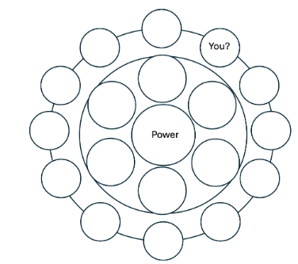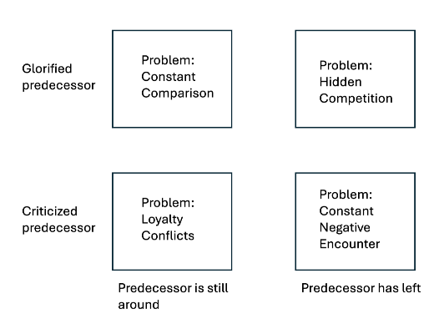

Figure 4.1 The Impact of Predecessors Figure 5.1 Power & Influence Map

Source: Fischer 2007

(69) No one has yet devised the perfect Questionnaire to diagnose what's commonly known as narcis sism. But it hardly matters. Most people can smell it from across the company cafeteria ... it's a familiar scent. (Carey 2010)

(76) The real power in your organization is located:

* Who goes to lunch with whom?
* Who interrupts whom at meetings?
* Who controls or has access to key people and private information?
* Who controls resources (budgets, money, people?

(79)

1. List the names of decision makers.
2. Figure out how you are connected to this group.
3. Determine how your boss is connected to this group.
4. Consider how or if your team is connected to this group.
5. Assess how visible you and your team are to this group.
6. Observe how this decision-making group thinks.
7. Try to determine what is of critical importance to this group.
8. Plot where you are on this map.

Not everybody is obsessed with power or money, but few people would refuse more of either if it were offered to them. (Dubrin 1990)

(81) Show up early and make connections. Here are three tips:

* Connect with intention.
* Connect equally.
* Connect with fairweather colleagues.

(86) There are three questions that we all need to think about:

1. How do you manage perceptions for your career progression?
2. How do you change perceptions?
3. How do you let others know you're changing?

(87) The BUT problem, the danger that attends those who are regarded as being technically competent "but" who are seen as lacking social and political sensitivity. (Buchanan 2008)

* High-potential talent groups.
* Executive-search consultants.
* Mentors, advocates and sponsors.

(90) What sets great leaders apart is their ability to manage perceptions. What people observe or assess as your ability to be a leader and your effectiveness becomes their perception, which in turn becomes reality. Perceptions that are not managed become rumors, then gossip, then backbiting, which leads to destruction. (Russell 2001)

(94) A 12-step program for changing perceptions and building your reputation:

1. Find a mentor, sponsor, advocate or coach and tap into your power network.
2. Determine what you want to be known for and develop a game plan for achieving it.
3. Find out what your enemies are saying about you.
4. Remember the adage "many a true word; listen for the "buts" and the meaning behind the words.
5. Talk openly (with those you trust) about your development.
6. Ask for regular feedback.
7. Do something completely out of character-if you're viewed as quiet, speak up at meetings. If you're known to be tough on subordinates, take more of an interest in their wellbeing and thank them publicly for their work.
8. Change your rituals. If you're often late-and known for it-come in early. The opposite applies equally.
9. Use humor as a means of making a point subtly/overcoming resistance.
10. Connect with your internal communications team or hire a PR firm.
11. Embark on a word-of-mouth campaign to promote yourself and your team.
12. Thank your supporters and sponsors.

**PERSONAL BRANDING**

(103) Your personal brand begins with your "Who am I?" and "Why am I here?" stories. you will need to spend time reflecting on your values, aspirations and experiences.

(109) The greatest cultural difference in intercultural communication is the degree of directness of speech acts. (Earley, Ang and Tan 2006)

(112) In Thai and other Asian cultures, positive politeness and other politeness strategies are used when disagreeing with someone. (Phukanchana 2004)

(113) Cultural differences and similarities of Trompenaars (1993) and Fisher-Yoshida and Geller (2009), variations across cultures.

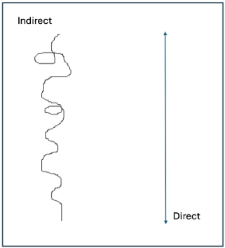

Figure 8.1 Chart depicting cultural differences and similarities of Trompenaars and Fisher-Yoshida & Geller.

(114 y 119)

|  |  |
| --- | --- |
| Direct about Indirect | Indirect about Direct |
| Not Trustworthy | Arrogant |
| Evasive | Not credible |
| Beating around the bush | Emotional |
| Vague | Blunt |
| Ambiguous | Confrontational |
| Reticent | Insensitive |

|  |  |
| --- | --- |
| MEN | WOMEN |
| Status | Connections |
| Power | Closeness |
| Independence | Intimacy |
| Win | Close |
| Avoid failure | Avoid isolation |
| Seek Control | Seek understanding |
| Adversarial | Synergistic |
| Transmit information | Maintain interaction |
| Advice | Connections |
| Prefer inequality | Prefer equality |

(115) Communication tips to increase your visibility and enhance your presence:

* The most obvious and overlooked point be prepared.
* Ditch the tentative talk. Think like your audience.
* Go in to every meeting with a goal to leave having asked a question, summed up the dialogue, given thoughts or themes, or having made a statement.
* Stop, listen and reframe: every statement can be reframed.

Shambaugh (2008) recommends not waiting for the right moment or the perfect words to voice an opinion.

(117) There are six areas of non-verbal communication across cultures: distance, touching, body position, gestures, facial expressions and eye contact.

(118) Tannen (1990) what makes women different from men linguistically is what makes women great in cross cultural leadership positions.

(124) Three key elements must be in place:

* Clear goals.
* Timely feedback.
* Rewards for good performers; measures for improving poor performers.

**POWER, POLITICS AND SEX**

(135) Sexual harassment has less to do with sex than it does with exerting power, and control over others.

(137) These are not isolated incidents. Indeed, it is so prevalent in some countries and some organizations that harassment and sexual politics have to be dealt with as part of day-to-day work. Even when individuals are not targeted personally they are often obliged to work in an environment where such behavior is tolerated.

(144) It may make sense to leave a hostile environment, but the underlying problem doesn't go away.

(145) Tips on how to handle psychological or sexual harassment.

* Remain professional at all times, or a little more formal than usual.
* Never think you need to entertain remarks, actions or comments or flirt with your manager to gain approval or advance your career.
* If you're not sure about the intent of a particular comment or action directed towards you, be brutally direct in drawing attention to it. or make a joke and move on.
* When appropriate, talk about your husband/kids/fiancé/partner.
* Being visible.
* is all part of savvy self-promotion. If you've been invited to an event and feel uncomfortable, invite a colleague male or female to go with you.
* Talk to your firm's ethics committee, HR department.

**CONCLUSION**

(148) Becoming savvy is not difficult to achieve, although it does require a willingness to step out of comfort zones and to confront and overcome fears and prejudices that may be so deep-seated that they are no longer recognized for what they are.

Understanding the nature of power and identifying where it lies within any given organization is a critical component of political savvy in the workplace.

(149) The focus needs to be on the meetings that take place before the crucial meeting.

(150) Everyone can read charts and interpret data, but the real skill is aligning the stakeholders thinking and beliefs. Behind-the-scenes networking and lobbying for support is critical to success.

Reframing power and politics begins with middle management.

While organizations continue to invest in leadership and management development, not much time is spent on understanding politics and power.

(154 y 155) Political savvy is a critical leadership skill and one that is always in demand.

**Simple steps:**

1. Make it your goal to ensure that everyone in the organization is politically savvy.
2. Create a culture where positive politics operates.
3. Create advocacy and mentors for all employees.
4. Rewrite job descriptions with savvy vocabulary and redesign management and leadership curriculums to include the development of savvy skills.
5. Develop orientation programs and processes for new or newly promoted employees.
6. Forget performance reviews, encourage conversations!