**THE MARKETING OF SERVICES**

**By Donald Cowell 1984**

* (14)

|  |  |  |
| --- | --- | --- |
|  | *The Marketing of Services* | |
|  | *Reasons for the growth in service industries* | |
| 1. | Increasing affluence | Greater demand for law care, carpet cleaning, and other services that consumers used to provide for themselves |
| 2. | More leisure time | Greater demand for travel agencies, travel resorts, adult education courses. |
| 3. | Higher percentage of woman in the labour force | Greater demand for day care nurseries, maid service, away-from-home meals. |
| 4. | Greater Life Expectancy | Greater demand for nursing homes and health care services |
| 5. | Greater complexity of products | Greater demand for skilled specialists to provide maintenance for such complex products as cars and home computers. |
| 7. | Greater concern about ecology and resource scarcity | Greater demand for purchased or leased services, such as door-to-door bus service and car rental instead of car ownership. |
| 8. | Increasing number of new products | The computer- sparked development of such service industries as programming, repair, and time sharing. |
| Source: Schoell, W.F. and Ivy, J.T., *Marketing: Contemporary Concepts and practices*, Allyn and Bacon, Boston, Mass. 1981, p. 277. | | |

* (27)

|  |  |  |
| --- | --- | --- |
| **What are *services*?** | | |
| *Some constraints on the management of services and ways of overcoming them* | | |
| *Characteristics of service* | *Some implications* | *Some means of overcoming characteristics* |
| Intangibility | Sampling difficult.  Places strain on promotional element of marketing mix.  No patents possible.  Difficult to judge price and quality in advance. | Focus on benefits.  Increase tangibility of service (e.g. physical representations of it).  Use brand names.  Use personalities to personalize the service.  Develop reputation. |
| Inseparability | Requires presence of producer.  Direct sale.  Limited scale of operations. | Learn to work in larger groups.  Work faster.  Train more competent service providers. |
| Heterogeneity | Standard depends upon who and when provided.  Difficult to assure quality | Careful personnel selection and training.  Ensure standards are monitored.  Pre-package service.  Mechanize and industrialize for quality control.  Emphasize bespoke features. |
| Perishability | Cannot be restored.  Problems with demand fluctuation. | Better match between supply and demand (e.g. price reductions of peak) |
| Ownership | Customer has access to but no ownership of activity or facility. | Stress advantages of non-ownership (e.g. easier payment systems) |

* (29)

***What are services?***

SELLER RELATED BASES

|  |  |  |
| --- | --- | --- |
| *Nature of enterprise* | *Functions performed* | *Income Source* |

Derived from market

Marketplus donations

Donations only

Taxations

Communication

Consulting

Educational

Financial

Health

Insurance

Private, for profit

Private, non-profit

Public, for profit

Public, non-profit

BUYER RELATED BASES

|  |  |  |
| --- | --- | --- |
| *Market type* | *Way in which service bought* | *Motives* |

Instrumental i.e.: means to an end

Expressive i.e.: an end in itself

Consumer market

Industrial market

Government market

Agricultural market

Convenience service

Shopping service

Specialty service

Unsought service

SERVICE RELATED BASES

|  |  |  |
| --- | --- | --- |
| *Service form* | *Human or machine based* | *High or low contact* |

High contact service

Low contact service

Uniform service

Bespoke service

Human centred service

Machine centred service

An illustration of some current ways of classifying services.

* (31)

|  |  |  |  |
| --- | --- | --- | --- |
| ***Service characteristics and their consequences*** | | | |
| *Characteristics* | *Organization* | *Client* | *Society* |
| Intangibility | 1 Inventory  2 Communication  3 Pricing/costing  4 Patent protection | 1 Confidence  2 Search process  3 Image  4 Word-of-mouth | 1 Control  2 Productivity  3 Inflation |
| Organization – client interface | 1 Interface complexity  2 Control of the environment | 1 Personalized relationship  2 Short-term captivity | 1 Networks and planning  2 Elimination of dysfunctions |
| User´s participation in production | 1 Standardization  2 Innovation and behavior change  3 Productivity and user behavior | 1 Dependence on rules and procedures  2 Identification | 1 Innovation and public policy  2 Involvement |
| Source: Eiglier, P. and Langeard, E. in *Marketing Consumer Services: New Insights*, MSI Report 77-115, 1977, Cambridge, Mass. | | | |

* (32)

Service A

Service B

Customer A

Customer B

|  |  |
| --- | --- |
| SERVICE ORGANIZATION | |
| *Invisible part* | *Visible part* |
| Internal Organizational System | Physical Environment |
| Contact Personnel |

Source: Based on Eiglier, P., and Langeard, E., *Principles de politique marketing pour les enterprises de services,* L´Institut d´Administration des Enterprises, Université d´Aix-Marseille, Décembre 1976, p. 11. (Working Paper presented at Marketing of Services Workshop, France)

* (33)

|  |  |  |
| --- | --- | --- |
| *What Are Services?* | | |
|  | *Corporate image* |  |
| **Auxiliary services**  Traditional personal selling  Pricing  PR and Sales promotion activities  Non – interactive communication  Interactive personnel/ customer  Accesibility of the services communication  Consumer influence | The service concept  (The core of the offering) |  |
|  | Market needs |  |

Source: Gronroos, C., “An Applied Service Marketing Theory”, Working Paper No. 57, Swedish School of Economics and Business Administration, Helsinki, 1980.

* (58)

|  |
| --- |
| *The Marketing of Services* |

1. Marketing objectives and strategies
2. Marketing objectives and strategies
3. Identify alternative plans and mixes
4. Programmes
5. Measurement and review
6. Assumptions

3. SWOT Analysis

2. Marketing audit

1. Corporate objectives

THE MARKETING PLANNING PROCESS

Figure 4.1. The Marketing Planning Process

Source: McDonald, M. and Gattorna, J. `Marketing: An Introduction for Accountants´, Institute Chartered Accountants, Milton Keynes, 1980, p. 77.

* (70)

***Exhibit 4.3***

***The marketing mix for services***

|  |  |  |  |  |  |  |
| --- | --- | --- | --- | --- | --- | --- |
| *Product* | *Price* | *Place* | *Promotion* | *People* | *Physical Evidence* | *Process* |
| Range  Quality  Level  Brand name  Service line  Warranty  After sales service | Level  Discounts   * Allowances * Comissions   Payment terms  Customer´s perceived value  Quality/price  Differentiation | Location  Accessibility  Distribution channels  Distribution coverage | Advertising  Personal selling  Sales promotion  Publicity  Public relations | Personnel:   * Training * Discretion * Commitment * Incentives * Appearance * Interpersonal behavior   Attitudes  Other customers  Behavior  Degree of involvement  Customer/customer contact | Environment   * Furnishings * Color * Layout * Noise Level   Facilitating   * Goods   Tangible clues | Policies  Procedures  Mechanization  Employee discretion  Customer involvement  Customer discretion  Flow of activities |

Source: Derived from Booms, B.H. and Bitner, M.J. “Marketing Strategies and Organization Structure for Service Firms” in Donnelly, J. and George, W.R. (Eds), *Marketing of Services, American Marketing Association,* Chicago, 1981.

* (75)

|  |
| --- |
| *Marketing Strategy and the Marketing Mix in Service Marketing* |

MARKETING AUDIT: The resources the firm can put against its market

Recycle ideas on basis of lessons learn at each stage

Recycle

Recycle

TEST APPEAL: Subject the hypotheses of the mix artists to empirical check

DESIGN MIX: Use mix concepts as a guide to management judgements in building marketing mixes

TARGET MARKET: Disciplined assessment of alternatives backed by research where possible

Figure 4.2 Building the Marketing Mix

Source: Derived from Cannon, T. *Basic Marketing: Principles and Practice, Holt, Rinehart & Winston,* New York, p. 159

* (80)

|  |
| --- |
| *Table 5.1*  *Distinction between Research and Intuition in Marketing Decision - making* |

|  |  |  |
| --- | --- | --- |
|  | *Research* | *Intuition* |
| Nature | Formal planning and predicting based on scientific approach | Narrow and immediate preference based on personal feelings |
| Methods | Logic, systematic methods, and statistical inference | Experience and demonstration |
| Contributions | General hypotheses for making predictions, classifying relevant variables, and systematic description and classification | Minor problems solved quickly through consideration of experience and practical consequences |

Source: Pride, W.M. and Ferrell, O.C. *Marketing: Basic Concepts and Decisions,* 3rd edn, Houghton Mifflin, Boston, Mass. 1983, p.107

* (83)

|  |
| --- |
| *Figure 5.1 The Research Process* |

Prepare report

Analyze data

Collect data

Sources of information

1. Secondary
2. Primary

Problem formulation

Research plan

Exploratory phase

Source: Crisp, R.D. *Marketing Research Organization and Operation,* Research Study No. 35, American Marketing Association, Chicago 1958

* (90) *Problems Deriving From the Characteristics of Services*

Particularly for new service development research designs are:

|  |  |
| --- | --- |
| *Characteristic* | *Effects upon Marketing Research* |
| Intangibility | 1. Where a dominantly intangible service, home use tests not appropriate. 2. Often appropriate to move directly from concept testing to test marketing in new product development. 3. “Researchability” problem for dominantly intangible services. |
| Patenting difficult | 1. Reduce incentives for large R&D investment. 2. More focus on “me too” services. 3. Tendency towards service improvement rather than innovation. 4. Ease of competitive entry influences viability of new service concepts. |
| Standardization difficult | 1. Difficult to develop accurate concept descriptions. 2. Problems in concept testing. |
| Direct relationship between service performer and client | 1. Judgements of service product influenced by who performs the service and the client´s involvement in performance. |
| No clear lines of demarcation between a service product and the place in which it is delivered, the process and the people | 1. Concept testing difficult because of need to assess impact of performer and physical evidence on service itself. |

These problems of measurement have led to the development of new techniques in marketing research.

CONCEPT TESTING STAGES

CONSUMER NEEDS ANALYSIS

IDEA GENERATION

PRELIMINAR ANALYSIS

Competitive

Internal

External

PRE – POSITIONING THE CONCEPT

FIELD STUDY

Personal interviews

Telephone surveys

Mail questionnaires

CONSUMER EVALUATION

Understanding

Reaction

Benefits

NEGATIVE

POSITIVE

TEST MARKETING OR INTRODUCTION

Source: Murphy, P.E. and Robinson, R.K. “Concept Testing for Services” in Donelly, K.H. and George, W.R. *Marketing of Services,* American Marketing Association, Chicago, 1981, p. 218

* (100)

|  |
| --- |
| *Figure 6.1 Conceptualizing The Service Product* |

|  |  |  |
| --- | --- | --- |
| Level 1 | CONSUMER BENEFIT  CONCEPT  Translated into | Considered with what benefits do, customers/clients seek |
| Level 2 | SERVICE CONCEPT  Translated into | Concerned with what general benefits will the service organization offer |
| Level 3 | SERVICE OFFER  Translated into | Concerned with more detailed shaping of the service concept. Decisions on, and clarification of:   * Service elements (Tangible and intangible) * Service forms (In what way/how) * Service levels (Quality and quantity) |
| Level 4 | ERVICE DELIVEY  SYSTEM | Creation and delivery of the service product using guidelines built into the service offer. Concerned with people, processes, facilities, etc. |

Source: Cowell, D. W. *The Marketing of Services, 1984. P.100*

* (103)

|  |
| --- |
| *Table 6.1*  *Terminology used to Describe the Service Product* |

|  |  |  |  |
| --- | --- | --- | --- |
| *Core product* | *Substantive service* | *Elementary services* | *Core service* |
| What is the buyer buying? | The essential function of the service | 1. Core services 2. Main reason why customer buys 3. Main output that the company provides | Consists of *general* service concepts and *specific* service concepts |
| *Tangible product*  Making the core product tangible to the buyer through:  Quality level  Features  Styling  Brand name  packaging | *Peripheral service*  Service that surrounds the substantive service | 1. Peripheral service offered around core service and adds to it some value | *Auxiliary service* Service used as a means of competition “Extras”. Not essential but can become an integral part of the offer |
| *Augmented product*  Additional benefits and services offered with the tangible products |  | *Global Service*  Set of core and peripheral services which constitute the service offering |  |
| Source:1  Kotler, P. *Principles of Marketing,* Prentice – Hall,  Englewood Cliffs,  1980, PP. 368-9 | Source:2  Sasser, W.E., Olsen, R.P. and Wyckoff, D.D., *Management of Service Operations – Text and Cases,* Allyn and Bacon, Boston, Mass. 1978 | Source:3  Eiglier, P. and Langeard, E. “A conceptual approach of the service offering” Working paper No. 217, iae Aix en – Provence, pp. 6-9 | Source:4  Grönroos, C. “An applied service marketing theory” Swedish School of Economics and Business Administration. Working Paper 57, 1980, pp. 12 - 14 |

Source: Cowell, D. W. *The Marketing of Services, 1984. P.103*

* (105)

|  |
| --- |
| Figure 6.2. Elements of The Service Offer |

Intangible

Tangible

|  |  |
| --- | --- |
|  |  |
|  |  |

Controllable

Uncontrollable

Influences

Desirable

Undesirable

|  |  |
| --- | --- |
|  |  |
|  |  |

Anticipated

Unanticipated

Source: Cowell, D. W. *The Marketing of Services, 1984. P.105*

* (106)

|  |
| --- |
| *Figure 6.3 Model of Tangibility/Intangibility Dominance* |

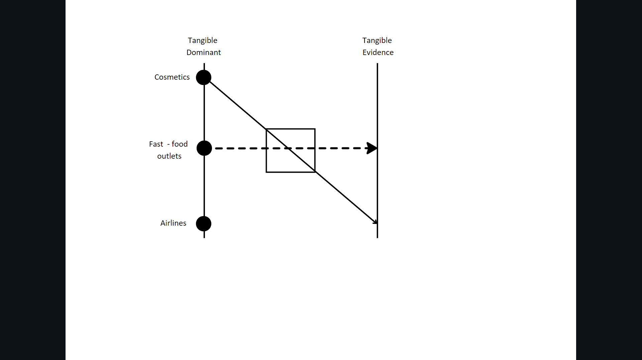

Source: Shostack, G.L. “Breaking Free from Product Marketing”, *Journal of Marketing*, Vol. 41, No 2, American Marketing Association, April 1977. Pp. 73-80

* (122)

|  |
| --- |
| *Table 7.1 New Service Options* |

|  |  |
| --- | --- |
| *Situation* | *Resource* |
| 1 Attempting to sell more existing services to existing clients  2 Attempting to sell existing services to new clients  3 Attempting to sell new services to existing clients  4 Attempting to sell new services in new markets | Existing capability, facilities, and market position  Existing capabilities and facilities. No market resources  Market resources, no existing capability or facility resource  Nil |

Source: Wilson, A. *The Marketing of Professional Services,* McGraw – Hill, London, 1972.

* (123)

|  |
| --- |
| *Table 7.2 Growth Vectors* |

|  |  |  |  |  |  |
| --- | --- | --- | --- | --- | --- |
|  |  |  | *Product* |  |  |
| Market | Present | Product modification   * Quality * Style * Performance | Product range   * Extension * Size variation * Variety variation | New products in related technology | New products in unrelated technologies |
| Present | Market – penetration strategies | Product – reformulation strategies | Product range – extension strategies | Product – development strategies | Lateral – diversification strategies |
| New | Market – development strategies | Market – extension strategies | Market segmentation – product differentiation strategies | Product – diversification strategies | Longitudinal – diversification strategies |
| Resource and/or distribution markets |  |  | Forward or backward integration strategies |  |  |

Source: Christopher, M., McDonald, M. and Wills, G. *Introducing Marketing,* Pan, London, 1980

* (127)

|  |
| --- |
| *Table 7.5 Illustrative Service Product Range* |

Width of range

|  |  |  |  |  |
| --- | --- | --- | --- | --- |
| *Customer groups* | | | | |
| *Infants* | *Children* | *Mixed Adults* | *Single Sex Adult Groups* | *Pensioners* |
| Creche | Swimming lesson | Badminton classes | Weight training | Exercise group |
| Socialization groups | Football league | Squash coaching | Karate | Bowls |
| Mother and child classes | Tennis tournaments | Squash league  Hockey teams | Slimming clubs | Social group |

Service

Product

Lines

Depth

Source: Cowell, D. W. *The Marketing of Services, 1984. P. 127*

* (130)

|  |
| --- |
| *Table 7.6 Comparison of Growth Paths for Service and Product – oriented firms* |

|  |  |
| --- | --- |
| *Service – Oriented Firm* | *Product – Oriented Firm* |
| Penetration | Penetration |
| Geographic market expansion | Geographic market expansion |
| Innovative redesign of existing services | Sociodemographic market expansion |
| New core service development | Innovative redesign of existing products |
| *Or* |  |
| Concentric diversification | Expand to out – of – country markets |
| Expand to out – of – the country markets | Concentric diversification |
| Conglomerate diversification | Conglomerate diversification |

Source: Carman, J.M. and Langeard, E. “Growth Strategies for Service Firms”, Proceedings of the 8th Annual Meeting of the European Academy for Advanced Research in Marketing, Groningen, 1979

* 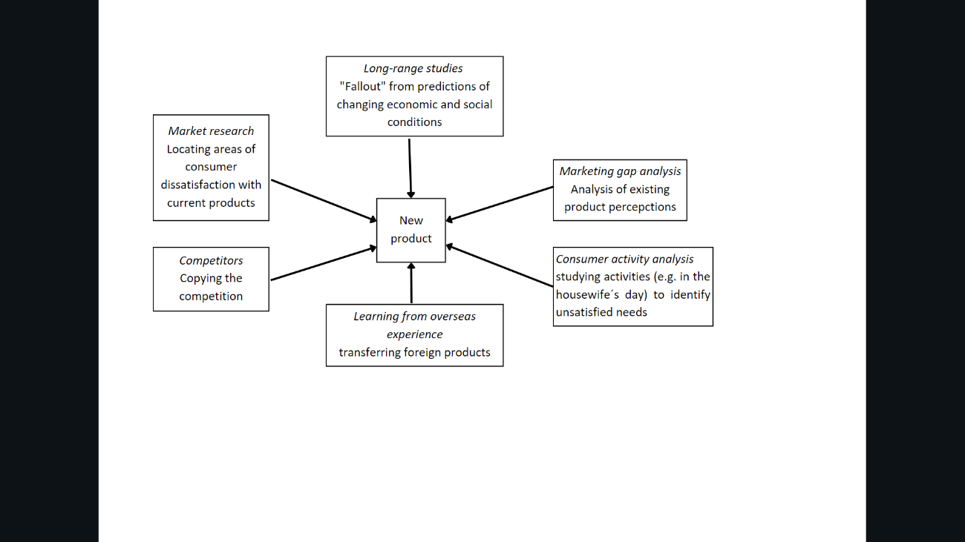(134)

|  |
| --- |
| *Table 7.4 External Sources of New Product Ideas* |

Source: Oliver, G. *Marketing Today,* Prentice – Hall, Englewood Cliffs, 1980.

* (159)

|  |
| --- |
| *Figure 8.1 Multistage Approach to Pricing* |

Company objectives related to product image

Marketing strategy; develop a marketing mix

Market opportunity analysis; selecting specific market targets

Developing and implementing pricing strategy

Choosing a specific price

Developing marketing plans; choosing a pricing policy

Source: Based on Oxendelft, A.R. “Multi – stage approach to Pricing”, *Harvard Business Review,* July – Aug. 1960, p. 125-33

* (187)

|  |
| --- |
| *Figure 10.2 Hotel Service Channels* |

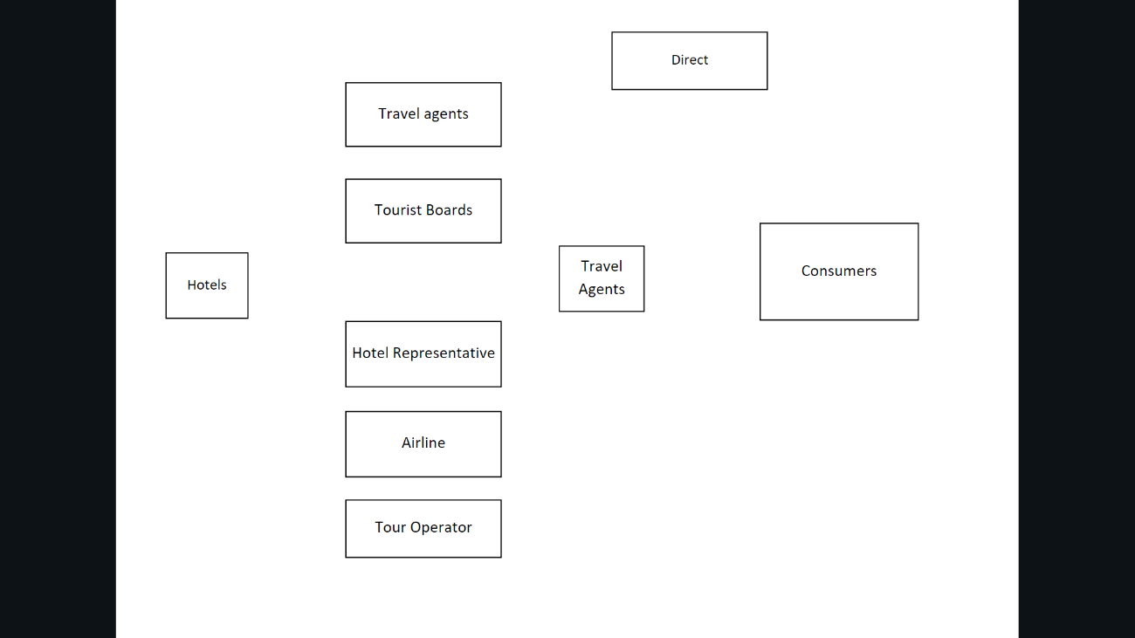

Source: Derived from Rathmell, J.M. *Marketing in the Service Sector,*  Winthrop, Cambridge, Mass., 1974

* (192)

|  |
| --- |
| *Table 10.1 Illustrative List of Business Franchise Operations* |

|  |  |
| --- | --- |
| Accounting and tax services | Motels |
| Beauty Salons | Nursing homes |
| Car rental services | Office systems |
| Drain cleaning services | Pest control |
| Employment services | Restaurants |
| Fast food operations | Sales training services |
| Glass tinting | Travel agencies |
| Hotels | Vending operations |
| Industrial services | Weight control systems |
| Lawn and garden care |  |

Source: Mendelsohn, M. *The Guide to Franchising,* 2nd edn, Pergamon, Oxford, 1979

* (204)

|  |
| --- |
| *Figure 11.1 Organization Personnel Involved in Service Product Performance and Delivery* |

*Non - contact with client*

*Contact with client*

|  |  |
| --- | --- |
| Waitress  Service engineer | Cook in steak house  Computer operator |
| Telephone Operator  Airline pilot | Maintenance worker  Accountant |

*Non - visible to client*

*Visible to client*

Source: Cowell, D. W. *The Marketing of Services, 1984. P. 204*

* (206)

|  |
| --- |
| *Figure 11.2 Managing the perceived service quality* |

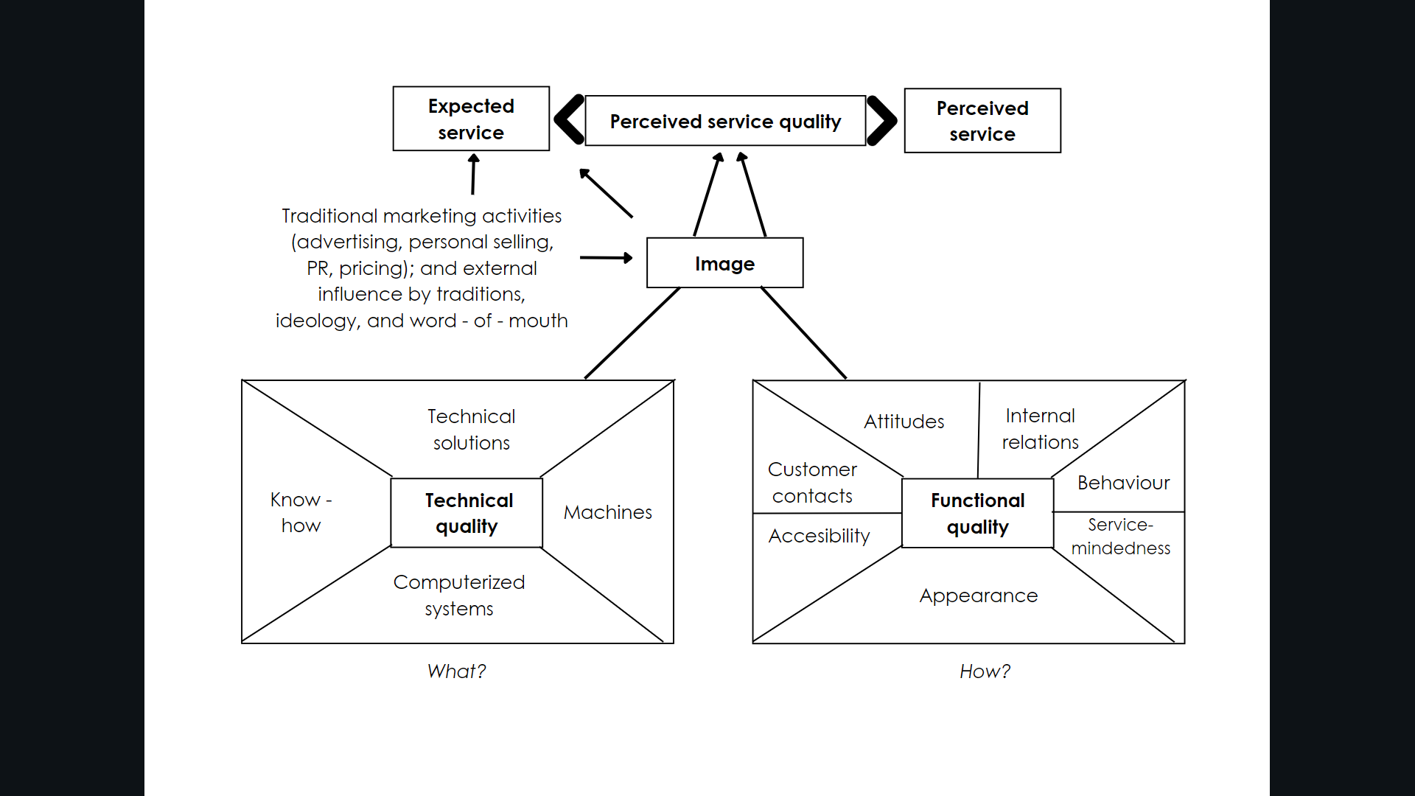

Source: Gronroos, C. “Strategic Management and Marketing in the Service Sector”, Swedish School of Economics and Business Administration, Helsinki, 1982.

* (209)

|  |
| --- |
| *Table 11.1 The Internal Marketing Concept – a Summary* |

|  |  |
| --- | --- |
| *Internal marketing*  Overall objective: | To get motivated and customer – conscious personnel. |
| *Strategic level*  Objective: | To create an internal environment which supports customer – consciousness and salesmindedness among the personnel   * Supporting management methods; * Supporting personnel policy; * Supporting internal training policy; * Supporting planning and control procedures. |
| *Tactical level*  Objective: | To sell services, supporting services (used as means of competition), campaigns and single marketing efforts to the employees.   * The personnel is the first market of the service company; * The employees must understand why they are expected to perform in a certain manner, or in a certain situation actively support, for example, a given service or supporting service; * The employees must accept the services and other activities of the company in order to be expected to support them in their contact with customers; * A service be fully developed and internally accepted before it is launched: * The internal information channels must work; * Personal selling is needed internally, too. |

Source: Gronroos, C. “Internal Marketing – An integral Part of Marketing Theory”, in Donnelly, J.H. and George, W.R. (eds), *Marketing of Services,* American Marketing Association, Chicago, 1981, p. 237

* (223)

|  |
| --- |
| *Figure 11.3 Consumption/Evaluation Process for Services* |

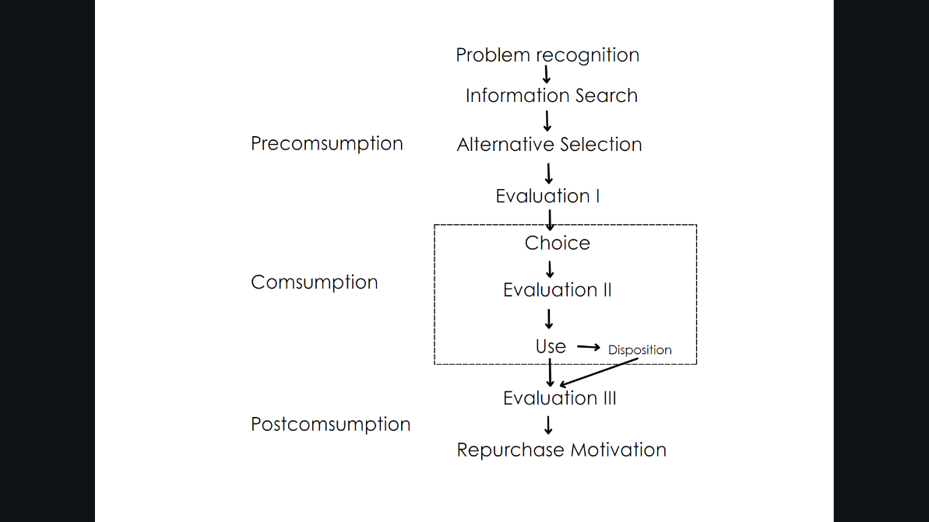

Source: Fisk, R.P., “Toward a consumption/ evaluation process model for services”, in Donnelly, J.H. and George, W.R. (Eds.) *Marketing of Services,* American Marketing Association, Chicago, 1981, pp. 191 - 95.

* (243)

|  |
| --- |
| *Figure 13.1 Operations System* |

*Inputs*

Materials

Labour

Machines

Power

Information

Technology

Products

Services

Resource

Conversion

Process

Operations management is concerned with systems design, operations planning, executions and control.

Source: Cowell, D. W. *The Marketing of Services, 1984. P. 243*

* (247)

|  |
| --- |
| *Actions to Balance Supply and Demand in Service Systems* |

|  |  |
| --- | --- |
| *Supply Side* | *Demand Side* |
| 1. Inventory wherever possible (e.g. spare capacity, people, etc.) | ´1 Have customers wait in favourable environments. |
| 1. Schedule workers according to demand (e.g. shift working, part-time employees) | ´2 Schedule customers (e.g. appointment systems) |
| 1. Subcontract work to other service organizations | ´3 Provide substitute good or services (e.g. automatic tellers) |
| 1. Have a peak-time efficiency routines (e.g. only do essential jobs) | ´4 Diversity demands (e.g. enter counter seasonal markets) |
| 1. Increase customer participation in the production process (e.g. self – service) | ´5 Turn customers away during peak demand period (e.g. differential pricing) |
| 1. Share services/facilities with other service organizations | ´6 Use marketing to shift demand (e.g. advertising campaigns) |
| 1. Improve the service system (e.g. use technology where possible) | ´7 Change customer expectations of service (e.g. through usage) |

(Based on various sources)

* (304)

|  |
| --- |
| *Figure 16.1 Productivity of Services: Output Measures* |

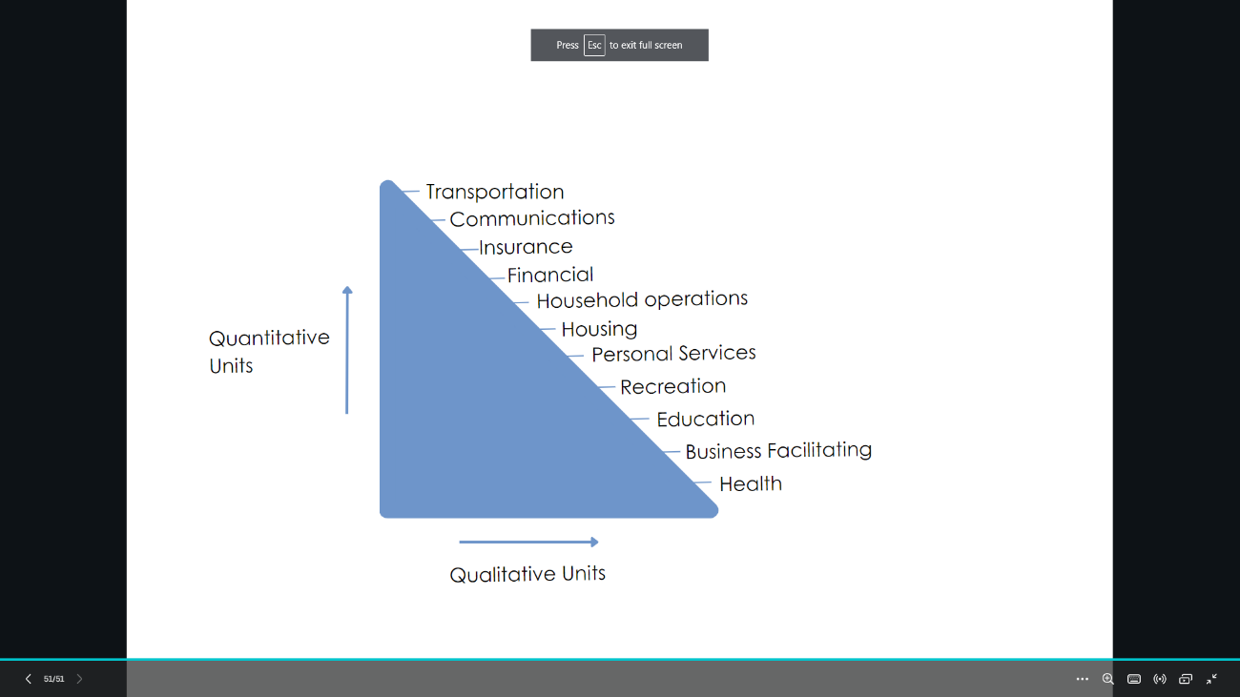

Source: Rathmell, J.M. *Marketing in the Service Sector,* Winthrop, Cambridge, Mass. 1974